DEVELOPMENT OF AN AI-DRIVEN STOCK INVESTMENT ADVISOR FOR YOUNG NIGERIANS USING HYBRID SENTIMENT AND MARKET TREND ANALYSIS

BY

EBO MOFIYINFOLUWA DAVID

(22CG031849)

A PROJECT SUBMITTED TO THE DEPARTMENT OF COMPUTER AND INFORMATION SCIENCES, COLLEGE OF SCIENCE AND TECHNOLOGY, COVENANT UNIVERSITY, OTA, OGUN STATE.

IN PARTIAL FULFILMENT OF THE REQUIREMENTS FOR THE AWARD OF THE BACHELOR OF SCIENCE (HONOURS) DEGREE IN COMPUTER SCIENCE

JUNE, 2026.

CERTIFICATION
I hereby certify that this project was carried out by Ebo, Mofiyinfoluwa David, in the Department of Computer and Information Sciences, College of Science and Technology, Covenant University, Ota, Ogun State, Nigeria, under my supervision.

Mr. Emmanuel O. Franklyn ___________________________
Supervisor Signature and Date

Prof. Aderonke A. Oni ___________________________
Head of Department Signature and Date

DEDICATION

This work is dedicated to the most high God for His providence and my loving friends and family for their everlasting support.

ACKNOWLEDGEMENTS

To the Almighty God, I give my gratitude for having provided me guidance and protection throughout my studies. From the inception of this course of study to the point in time, God's grace saw me through, and all the praises go to Him. I must give my undying thanks to my parents for all their sacrifices towards my education.
I am so grateful to my supervisor, Mr Emmanuel O. Franklyn, for all his timely and wise advice and intellectual input in this project; for guiding me during this project work, and for his critiques and useful comments. I am so grateful to Mr Ebuka Ejoibih for his encouragement and contributions during this project work.

TABLE OF CONTENTS
CONTENT PAGES
CERTIFICATION ii
DEDICATION iii
ACKNOWLEDGEMENTS iv
TABLE OF CONTENTS v
LIST OF FIGURES viii
LIST OF TABLES ix
ABBREVIATIONS x
ABSTRACT xii
CHAPTER ONE 1
1.1. Background information 1
1.2. Statement of the problem 2
1.3. Aim and objectives of the study 3
1.4. Methodology 4
1.5. Significance of the study 7
1.6. Project outline 8
CHAPTER TWO 9
2.1. Preamble 9
2.2. Review of Intelligent Financial Advisory Systems (Robo-Advisors) 9
2.2.1. Definition and Evolution of Robo-Advisors 9
2.2.2. Core Functionalities and Benefits of Robo-Advisors 10
2.3. Review of Stock Market Prediction Techniques 12
2.3.1. Traditional versus AI-Based Stock Market Prediction Techniques 12
2.3.2. Machine Learning and Deep Learning Models for Prediction 14
2.4. Review of Relevant Concepts 15
2.4.1. Machine Learning and Artificial Intelligence 15
2.4.2. Natural Language Processing and Sentiment Analysis 15
2.4.3. Deep Learning and Transformer models 16
2.5. Review of Related Methods 18
2.5.1. Sentiment Analysis Methodologies 18
2.5.2. Hybrid and Multimodal Learning for Prediction 18
2.5.3. Predictive Modelling Techniques 19
2.6. Review of Existing Systems 21
2.6.1. Decision Support Systems 21
2.6.2. Hybrid and Sentiment-Driven Platform Support Systems 21
2.6.3. Limitations of Generic Large Language Models 25
2.7. The HybStockAdvisor System 25
2.7.1. Core Features and Components 26
2.7.2. Addressing Identified Problems 26
2.8. Summary of Literature Review 27
CHAPTER THREE 28
3.1. Preamble 28
3.2. Requirement Analysis 29
3.2.1. Functional Requirements 29
3.2.2. Non-Functional Requirements 29
3.3. System Architecture 30
3.3.1. Multi-Source Data Ingestion Layer 31
3.3.2. The Sentiment Data Pipeline 31
3.3.3. The Market Data Pipeline 32
3.3.4. The Feature Fusion Layer 32
3.3.5. The Machine Learning Prediction Layer 32
3.3.6. The Recommendation Layer (Safety Index Engine) 33
3.3.7. The Dashboard Output Layer 34
3.4. Dataset Description and Preprocessing 34
3.4.1. Dataset Sources 35
3.4.2. Dataset Structure 35
3.4.3. Preprocessing Techniques 36
3.5. Hybrid Model Architecture 37
3.5.1. The Natural Language Processing Branch (Naija-FinBERT) 38
3.5.2. The Predictive Classification Branch (LightGBM) 39
3.5.3. Feature Integration and Fusion Strategy 39
3.6. Model Development and Training 39
3.6.1. Algorithms Used 40
3.6.2. Training Process and Configuration 41
3.6.3. Model Output and Justification 41
3.7. System Evaluation Strategy 42
3.7.1. Model Evaluation Metrics 42
3.7.2. System Performance Metrics 43
3.7.3. Live Execution Evaluation 43
3.8. UML Modelling 43
3.8.1. Use Case Diagram 44
3.8.2. Activity Diagram 45
3.9. System Implementation Flow 46
3.10. Summary 47
CHAPTER FOUR 48
4.1. Preamble 48
4.2. System Requirements and Implementation Tools 48
4.2.1. System Requirements 48
4.2.2. Implementation Tools 49
4.3. Implementation Results 49
4.4. Model Evaluation Results 54
4.4.1. Model Comparison Results 54
4.4.2. Confusion Matrix Analysis 54
4.4.3. Live Market Execution Results 55
4.5. System Performance Evaluation 56
4.6. Discussion of Results 57
4.6.1. Effectiveness of Hybrid Model 57
4.6.2. Model Comparison Discussion 57
4.6.3. Impact of Sentiment Analysis 58
4.6.4. System Usability 58
4.7. Summary of Findings 58
CHAPTER FIVE 59
5.1. Preamble 59
5.2. Summary of Findings 59
5.3. Conclusion 60
5.4. Limitations of the study 60
5.5. Recommendations for Future Work 61
REFERENCES 63

LIST OF FIGURES

FIGURES | TITLES OF FIGURES | PAGES
2.1 | How a Robo-Advisor Works | 11
2.2 | Taxonomy of Stock Market Prediction Techniques | 14
2.3 | High-level architecture of a FinBERT model | 17
2.4 | Hybrid Fusion Model | 19
2.5 | ASPENDYS | 22
2.6 | Qlib | 22
2.7 | FinBERT LSTM Frameworks | 23
3.1 | Project Workflow | 28
3.2 | Project Methodology | 31
3.3 | The structural flow of the Hybrid model Architecture | 38
3.4 | Performance and comparative analysis of the 5 models | 42
3.5 | Model Evaluation Workflow showing the flow from training to metrics output | 43
3.6 | Sequence Diagram showing the flow between User, API, Model and Response lifecycle | 43
3.7 | Use Case Diagram | 45
3.8 | Project Walkthrough Diagram | 46
4.1 | Mobile App Dashboard | 50
4.2 | Explainable AI Screen using AI Insights to avoid Blackbox problem | 51
4.3 | Portfolio Screen and Asset Breakdown | 52
4.4 | AI Chat Screen | 53
4.5 | Model Comparison | 54
4.6 | Portfolio ROI Breakdown | 56

LIST OF TABLES

TABLES | TITLES OF TABLES | PAGES
1.1 | Objectives-Methodology Mapping Table | 6
2.1 | AI Techniques Used in Recommendation Systems | 12
2.2 | Comparison Table on Existing Systems and My System | 23
3.1 | Investment Safety Index Weighting Formula | 34
3.2 | Raw Dataset Structure | 35
3.3 | Processed Dataset Feature Matrix | 36
3.4 | Evaluated Machine Learning Classifiers | 40
4.1 | LightGBM Confusion Matrix Metrics | 55

ABBREVIATIONS

API | Application Programming Interface
AI | Artificial Intelligence
FinTech | Financial Technology
ML | Machine Learning
EMA | Exponential Moving Average
RSI | Relative Strong Index
DL | Deep Learning
NLP | Natural Language Processing
LSTM | Long Short-Term Memory
FinBERT | Financial Bidirectional Encoder Representations from Transformers
GPT | Generative Pre-trained Transformer
MACD | Moving Average Convergence Divergence
RF | Random Forest
XGBoost | eXtreme Gradient Boosting
SMP | Stock Market Prediction
XAI | Explainable AI
FOMO | Fear of Missing Out
LR | Logistic Regression
SVM | Support Vector Machines
CNN | Convolutional Neural Networks
GRU | Gated Recurrent Units
BERT | Bidirectional Encoder Representations from Transformers
ARIMA | Autoregressive Integrated Moving Average
KDF | Key Decision Factor
ANFIS | Adaptive Neuro-Fuzzy Inference System
ROI | Return on Investment
MAPE | Mean Absolute Percentage Error
UI | User Interface
NGX | Nigerian Stock Exchange
LLM | Large Language Model
RAD | Rapid Application Methodology
MPT | Modern Portfolio Theory
TF-IDF | Term Frequency Inverse Document Frequency
RMSE | Root Mean Square Error
MAE | Mean Absolute Error
RS | Recommendation System
OHLC | Open High Low Close
GTCO | Guaranty Trust Holding Company
JSON | Javascript Object Notation
REST | Representational State Transfer
JWT | JSON Web Token
UML | Unified Modelling Language
QoS | Quality of Service
CPU | Central Processing Unit
RAM | Random Access Memory
SSD | Solid State Drive

ABSTRACT
The participation of young retail investors on the Nigerian Stock Exchange is frequently hindered by the complexity of traditional finance models and the high volatility of emerging markets. Consequently, these novice traders tend to invest based on emotional market swings and unverified social media buzz, leading to significant capital losses. This project aims to develop an AI-driven stock investment advisor utilising a hybrid forecasting architecture to demystify sophisticated quantitative analysis. The methodology combined quantitative price action from financial platforms with qualitative public commentary scraped from localised online forums like Nairaland and Reddit. A fine-tuned natural language processing model, Naija FinBERT, extracted localised sentiment polarity, which was then mathematically integrated with technical indicators such as the Relative Strength Index and Exponential Moving Averages. This multi-modal dataset trained a LightGBM classification model to calculate a stable Investment Safety Index predicting upward price momentum, which was subsequently deployed via a cloud-based backend to a mobile application featuring a conversational AI Copilot. Empirical evaluations demonstrated the superiority of the LightGBM classifier over statistical baselines, achieving an F1 score of 0.6099 and perfect recall on highly liquid stocks. Furthermore, real-world backtesting confirmed financial feasibility, while system testing validated low-latency execution. The findings prove that fusing behavioural economics with technical analysis creates a highly stable, risk-aware prediction ecosystem that empowers retail traders to close the knowledge gap in African wealth creation.
Keywords: Artificial Intelligence, Sentiment Analysis, LightGBM, Algorithmic Trading, Retail Investing, Financial Technology.

CHAPTER ONE
INTRODUCTION

1.1. Background Information
The role of AI and the emergence of Financial Technology (FinTech) are changing the course of the financial industry and the way it operates (Jain & Vanzara, 2023; Sayyed, 2024). Artificial intelligence systems are leading a paradigm shift in how financial decisions are made and decisions are assisted. They provide services with automated and personalised guidance and investment strategies. Such developments in FinTech and AI are leading to algorithm-based investment planning services. These Robo-Advisors are democratising access to financial planning and wealth management services (Khadri & Reddy, 2024)
Robo-Advisors employ Machine Learning (ML) and big data analytics to personalise and tailor investment strategies for users. These Robo-advisors move beyond just normal algorithmic trading, which makes them very appealing to the younger generation and millennials (Khadri & Reddy, 2024). This reduces the usual barriers to entry, allowing even individual investors who are beginners to participate in the market without paying expensive brokers.
Historically, financial markets are highly information-driven, meaning that financial news and information play a very critical role in shaping and influencing investor behaviour, expectations and market behaviour (Qi, 2025). Consequently, analysing the sentiment embedded in financial news has become a very important task for understanding and predicting market dynamics (Cristescu, Nerisanu, Mara, & Oprea, 2022). In the past, investment decisions were influenced by factors such as fundamental and technical analyses, but these methods struggled to interpret the vast amounts of unstructured textual data generated from various media sources, including social media and news articles (Jain & Vanzara, 2023).
Consequently, the academic and financial research frontier has shifted toward hybrid models (Nyakurukwa & Seetharam, 2023). These models combine traditional market trend analysis (such as historical price data) with textual sentiment data from news and social media (Jain & Vanzara, 2023). Advanced AI techniques, particularly deep learning models like Long Short-Term Memory (LSTM) and Transformer-based models like FinBERT (Financial Bidirectional Encoder Representations from Transformers), have become central to this field. These models are used to analyse market sentiment, forecast trends, and improve prediction accuracy over traditional methods (Puh & Bagić, 2023).
AI-powered systems offer several advantages, including the democratisation of financial advice, which can be widely available not only to a large population but also to the youth generation who would have low investmentable asset levels (Khadri & Reddy, 2024). Accessibility of quality financial advice is a particularly relevant aspect when looking into the market of emerging countries and young people who may not have access to expert knowledge in the financial industry or a sophisticated decision support system. These advanced hybrid AI and NLP techniques have been utilised in the project so that customised and data-driven financial advice for the youth population can be provided.

1.2. Statement of the Problem
It becomes obvious that there is a clear need for an intelligent investment decision-support solution with the combination of rising interest of the young generation in the stock market and the increasing sophistication of the dynamics of financial markets. The problem statement is rather complex and described as follows:
- Lack of Financial Knowledge and Intelligent Systems for Young Investors: In many less developed regions, like Nigeria, young adults are investing in the stock market with an increasing level of interest. However, most of the less developed regions have less experience in stock market investing, a lack of adequate financial knowledge and an intelligent decision-support system. The advisory systems do not provide much specific and actionable insights during times of high market volatility(Kharatmol, Mhatre, Khairnar, & Bhosle, 2025).
- Lack of Contextual Insight in Existing Platforms: Traditional brokers or platforms merely display returns or historical data at certain periods without analysing the current sentiment or inherent risk. The financial decision-making process is often complex and includes variables which are unobservable, like investor sentiment, and have to be estimated based on available proxies. Predictions which only rely on quantitative data lack predictive power(Nyakurukwa & Seetharam, 2023).
- Failure to Integrate Hybrid Data Sources: It is evident that the public's sentiment is strongly correlated with the trends in the stock market. Specifically, online social media sites such as Twitter and Reddit, where investors discuss potential investment opportunities, significantly influence investor behaviours. However, the literature gap, both theoretical and practical, is clearly evident concerning a system which takes the data in the form of historical stock prices along with general sentiment from news websites and social media, to recommend financial investments(Theodorou et al., 2021).
- Absence of Locally Relevant AI-Powered Solutions: Currently, no such solution exists locally in Nigeria which has a well-built AI system analysing sentiments sourced from news websites, social media, and various other technical indicators in the stock market to aid in the investment decisions of young, small investors in the stock markets. Globally, AI models (like ChatGPT, Google Gemini, Claude AI) are too general and cannot analyse, fuse and make predictions which are contextually correct in a localised setting and domain like Nigerian stock markets(Hussen, Sewunetie, Ayele, Imam, & Hassan Muhammad, 2025; Shobayo, Adeyemi-Longe, Popoola, & Ogunleye, 2024).
These studies demonstrate the requirement of a hybrid AI model that will include sentiments from financial news websites and social media in addition to the basic financial information. With indicators such as exponential moving averages, relative strength index and MACD, this will be able to forecast region-specific indications and analyse the risk for the Nigerian youth investor.

1.3. Aim and Objectives of the Study
This project aims to develop an AI-powered stock investment advisor that analyses financial trends and public sentiment to provide data-driven, personalised insights and stock recommendations for young Nigerian investors. The objectives are to:
- Collect and preprocess historical and real-time stock market data from financial APIs.
- Acquire and analyse sentiment data from social media and financial news sources using NLP techniques.
- Design a hybrid model architecture that integrates sentiment analysis outputs with technical market indicators for improved prediction.
- Generate stock investment recommendations and risk scores using a trained machine learning classification model.
- Develop and evaluate a functional dashboard interface that visualises trends, sentiment insights, and recommendations.

1.4. Methodology
The development of this AI-driven stock investment advisor used the RAD methodology because of the way the model, interface, and data were repeatedly modified in cycles. This framework is suited to enable quick switching between analytical prototyping, continuous software testing and user requirements changes. A hybrid AI model, as central to this process, is created and verified. The methodological design framework for this project consists of 5 phases:
- Data Collection and Preprocessing of Market Data: This stage involves gathering historical and real-time stock data from public financial APIs such as AlphaVantage, Yahoo Finance (Li, Yu, Xu, Liu, & Mo, 2023). The raw data usually contains missing values, noise data from irregular market days (Zepeng, Zhiyuan, Jiajia, Ke, & Yong, 2025). Then we preprocess the data by handling missing entries through interpolation, converting timestamps into uniform formats and computing other features (D. Shah, Isah, & Zulkernine, 2019).
- Sentiment Data Acquisition & Processing: Public sentiment significantly influences stock market behaviour, especially among young investors (Qi, 2025). This study extracts sentiment data from investment communities on Reddit and financial websites. This study utilises snscrape and BeautifulSoup to scrape relevant financial data. The data went through the tokenisation, lowercasing and emoji/slang handling processes. This study also utilises FinBERT to determine the sentiment polarity (positive, neutral, negative).
Sentiment analysis was utilised because sentiment influences short-term stock movements. Young investors are usually influenced by social media news and market rumours (Qi, 2025). A study by Theodorou et al. (2021) shows that sentiment analysis on Twitter data has a strong correlation between the rise and fall of stock prices based on the sentiment expressed in the tweets.
- Hybrid Model Design (Data Fusion): This stage combined the market indicators, such as EMA, RSI, and MACD, with the sentiment polarity and confidence scores. Using just either market trend analysis or just sentiment analysis alone isn’t a reliable method because sentiment analysis reveals emotional behaviours towards that particular stock, while market trend analysis shows the price strengths and trends of that particular stock (Mohan, Mullapudi, Sammeta, Vijayvergia, & Anastasiu, 2019). Incorporating market trend analysis and sentiment analysis drastically increases the prediction accuracy of the model, which leads to huge performance improvements and improved Return on Investment (ROI) (Nti, Adekoya, & Weyori, 2020; Qi, 2025).
- Predictive Modelling: The driving engine where multi-modal data will be integrated and passed through machine learning algorithms to provide useful capital markets predictions. A comparative framework is in place to evaluate five different classifiers, namely, Logistic Regression, AdaBoost, Random Forest, XGBoost and LightGBM, on the concatenated hybrid feature matrix and translate these into explicit buy, hold or sell signals. This output from the champion model in terms of its prediction confidence would be concatenated with real-time volatility figures of the market to provide an Investment Safety Index on a scale of zero to one hundred. An explanation engine would then pick up the respective tree paths and construct natural language explanations regarding why the calculated index score is either low, medium or high.
- System Development and Evaluation: This study has a Flutter mobile dashboard with the backend built in FastAPI. The dashboard has the different sentiment trends, Buy/Hold/Sell predictions, risk scores, trend charts, recommended action to be taken, as well as the risk safety indicators.
The system would also be tested at two stages:
  - Model Evaluation: Here, the model would be evaluated based on accuracy, F1-score, confusion matrix, and comparison with labelled benchmark datasets (manual annotation or publicly available financial sentiment datasets). Model reliability is ensured through a time-series split validation strategy, detailed in Chapter Three
  - System Performance and Usability Testing: The project would be tested based on the API load time, the dashboard responsiveness, the project stability under concurrent requests and user feedback. The project would also be tested using standard metrics such as the System Usability Scale, task-completion tests, and feedback interviews with sample users.
The specific methodological steps aligned with each research objective are summarised in Table 1.1

Table 1.1: Objectives-Methodology Mapping Table

S/N | Objectives | Methodology
1. | To collect and preprocess historical and real-time stock market data from financial APIs. | Data Collection & Preparation  - Gather stock data using APIs such as Alpha Vantage or Yahoo Finance .  - Perform data cleaning, handling missing values, formatting timestamps, and feature scaling
2. | To acquire and analyse sentiment data from social media and financial news sources using NLP techniques. | Sentiment Data Acquisition & Preprocessing  - Extract tweets, Reddit posts, and financial news using Tweepy, snscrape, and BeautifulSoup.  - Clean and standardise text (tokenising, lowercasing, emoji/slang handling, removing URLs).  - Apply FinBERT or a domain-specific transformer for sentiment scoring (positive/neutral/negative).
3. | To design a hybrid model that integrates sentiment analysis outputs with technical market indicators. | Hybrid Model Design (Data Fusion)  - Compute technical indicators such as EMA, RSI, and MACD  - Fuse sentiment polarity scores with market indicators into a unified structured dataset  - Prepare final feature set for hybrid predictive modelling.
4. | To generate stock investment recommendations and risk scores using machine learning classifiers. | Predictive Modelling and Scoring  - Train Random Forest, GradientBoost, XGBoost, AdaBoost, Logistic Regression models, perform a comparative analysis and select the optimal model to classify Buy/Hold/Sell signals.  - Model confidence and volatility should be used to build an "Investment Safety Index" from 0-100.
5. | To develop and evaluate a functional dashboard interface that visualises trends, sentiment insights, and recommendations. | Frontend Implementation  - Frontend Development: Build a Flutter mobile dashboard; backend implemented in FastAPI.  - Sentiment Evaluation: Evaluate sentiment model performance using Accuracy, F1-score, confusion matrix and benchmark with labelled dataset (manually labelled or using financial sentiment public dataset).  - Hybrid Model Evaluation: Backtest with historical prices data and analysis on precision, recall, F1-score, and directional accuracy  - App Evaluation: Conduct usability testing using standard metrics such as System Usability Scale, task-completion tests, and feedback interviews with sample users.  - Performance Testing: Assess dashboard responsiveness, API load time, sentiment data refresh rate, and mobile performance stability

Significance of the Study
The significance and relevance of this project are undeniable across various domains, particularly owing to its emphasis on bridging advanced AI research with specific, local financial needs.
- For the Investors (Young Nigerians): The paramount significance is the democratisation of financial intelligence (Khadri & Reddy, 2024). It offers ease in the sophisticated decision-making process involved in investing to young Nigerian investors in the form of actionable data-backed insights that were previously inaccessible due to either a lack of financial know-how or the cost of engaging human experts. It further assists users in easily and confidently achieving financial goals.
- For FinTech and Emerging Markets: A new AI-powered stock recommendation system designed with emerging market-specific knowledge (local context, such as the Nigerian capital market) has been brought to the fore, an area that seems lacking in existing models designed for general use (Pangavhane et al., 2023). The system provides users with a competitive edge by catering to domain-specific needs (Pangavhane et al., 2023).
- For Academia and Research: Academically, the project proposes a hybridised demonstration of sentiment analysis (unstructured data) and market analysis (structured data) for financial intelligence, which is an aspect of paramount importance in improving the AI-driven prediction of financial markets (Shobayo et al., 2024). It contributes to understanding how NLP-based models (such as FinBERT) can be synergised with numerical machine learning models such as XGBoost within a classification framework to deliver useful results (Shobayo et al., 2024).
- For the Economy: Through delivering data-driven information and improving financial literacy by guiding and providing education, this can ensure the Nigerian capital market becomes more investor-inclusive (Kharatmol et al., 2025), leading to more sound decisions that can lessen irrational, emotionally-driven and prejudiced decision-making habits found in human investors (Khadri & Reddy, 2024).

Project Outline
The project is divided into 5 chapters as follows: The first chapter includes the background of the project, the statement of the problem, the aims and objectives of the study, the methods and the significance. Chapter Two systematically studies relevant previous works, such as the origin and development of intelligent financial advising ( robo-advisors), stock market prediction methods (both traditional methods and AI-based methods), the use of sentiment analysis and NLP in finance and relevant challenges and research gaps. Chapter Three contains the system analysis, system design and the model architecture, data pipeline and algorithmic fusion strategy. Chapter Four describes the implementation, experiment setup, results and performance evaluation of the system. And Chapter Five contains the conclusion, the results and the future work.

CHAPTER TWO

LITERATURE REVIEW

Preamble
AI has impacted the financial service sector as a new, potent tool, being developed for automated, personalised investment decision-making (Pangavhane et al., 2023). In this chapter, we will review relevant literature on the design of the AI-driven Stock Investment Advisor in three main research domains: Intelligent Financial Advisory System (Robo-Advisors), technical challenges and considerations of Stock Market Prediction (SMP) and the significance of Sentiment Analysis and Natural Language Processing (NLP) on building financial intelligence. It serves as a base to justify the theoretical context and research gaps that are aimed to be addressed through a Hybrid Model methodology.

Review of Intelligent Financial Advisory Systems (Robo-Advisors)
The most radical innovation in FinTech in the last ten years is intelligent financial advisor systems, also known as robo-advisors (George, 2024; Kashyap, 2025)

Definition and Evolution of Robo-Advisors
Robo-advisors are known to be computer-automated financial advisory systems(George, 2024). Robo-advisors operate using machine learning, data science, and algorithms to develop an investment portfolio for users (George,2024). They are digital platforms that provide online, algorithm-driven financial investment services with minimal to no need for human intervention (Khadri & Reddy, 2024). The main reasons these systems exist include enhanced accessibility, affordability, and investments personalised and tailored to users when compared to traditional human financial advisors.
The concept of robo-advisors originated in the United States around 2008, which also coincided with the development of cloud computing and data analytics (George, 2024; Zepeng et al., 2025). Early pioneers like Betterment and Wealthfront offered low-cost, automated portfolio management using passive strategies and basic algorithm models informed by the Modern Portfolio Theory (MPT) (Sayyed, 2024).
The evolution of robo-advisory systems can be classified based on technological advancement:
- Rule-based Algorithms (2008-2010): These algorithms focused on automating tasks like rebalancing and tax-loss harvesting based on predefined rules(Kashyap, 2025;)
- Machine Learning Integration (2011-2015): Machine learning models, such as Linear Regression and Decision Trees, were incorporated to generate investment recommendations and risk profiling (Sayyed, 2024)
- Deep Learning (DL) and Natural Language Processing (2016-2018): During this time, neural networks and natural language processing were adopted to facilitate chatbots and early types of predictive analysis (Sayyed, 2024)
- Advanced Deep Learning (DL) and Sentiment Analysis (2019-2024): Sophisticated models like LSTM Networks and sentiment analysis were utilised for real-time market trend analysis (Banoth & Yadala, 2024)
- Explainable AI (XAI) and Hybrid Models (2022-2024): This phase addressed the black box problem of complex AI (Zepeng et al., 2025). Explainable AI frameworks were integrated to explain and provide clear rationales for investment decisions to foster user trust (Zepeng et al., 2025). Hybrid models combining artificial intelligence and human intervention also gained prominence.
Looking ahead, research expects the integration of Generative AI (GPT-5+), Quantum computing and the blockchain for more customisation and enhanced portfolio optimisation (Zepeng et al., 2025).

Core Functionalities and Benefits of Robo-Advisors
AI-driven Robo-Advisors are supported by machine learning, NLP, and big data analytics.
Some of the core functions of robo-advisors are:
- Automated Wealth Management: These include asset allocation, where investments are distributed across classes to balance risk and return (Kashyap, 2025; Zepeng et al., 2025). It also performs portfolio rebalancing and tax-loss harvesting (selling assets at a loss to offset capital gains) (Kashyap, 2025).
- Personalised Investment Strategies: Artificial intelligence leverages Machine Learning, Natural Language Processing and other techniques to analyse data to create personalised investment portfolios (Kharatmol et al., 2025; Zepeng et al., 2025). The strategies can adjust dynamically based on the market conditions and trends (Khadri & Reddy, 2024).
- Risk Management: Advanced risk assessment models using big data analytics allow for various types of testing, scenario analysis to ensure portfolios are resilient to volatility(Zepeng et al., 2025). Artificial intelligence can manage and monitor real-time market fluctuations and sentiments to detect potential risks.
- Market Trend Analysis and Predictive Analysis: Robo-Advisors use predictive analysis to predict market movements, and they utilise big data to identify patterns/market trends (Kashyap, 2025; Pangavhane et al., 2023).
Figure 2.1 shows how a Robo-Advisor works and the architecture
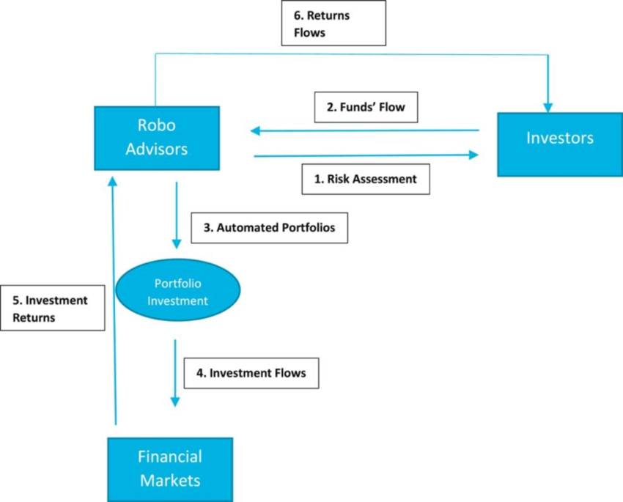
Figure 2.1: How a Robo-Advisor Works (Pattnaik & Hota, 2025)
Some of the advantages that robo-advisors have over traditional systems are:
- Democratisation and Accessibility: They lower the costs and increase the accessibility of professional financial planning services to a broader audience, which includes small to medium investors (Kashyap, 2025).
- Enhanced Precision and Speed: Artificial intelligence can rapidly react to market changes and make necessary adjustments in milliseconds without the need for human intervention (Khadri & Reddy, 2024).
- Mitigation of Behavioural Biases: AI algorithms can detect and counteract cognitive biases in human investors, such as FOMO (Fear of Missing Out), overconfidence and promote more rational investment decisions (Khadri & Reddy, 2024; Pangavhane et al., 2023).

Review of Stock Market Prediction Techniques
The accurate prediction of stock market trends is crucial for successful investment strategies. This project focuses on utilising AI techniques to predict stock movements and provide advice (Jain & Vanzara, 2023).

Traditional versus AI-Based Stock Market Prediction Techniques
Traditionally, Stock market prediction relied on two approaches, and both approaches have their limitations:
- Fundamental Analysis: This analysis focuses on the quantitative analysis of a company’s finances (balance sheets, profits) and other factors like interest rates, inflation to analyse future stock trading (Shah, Vaidya, & Shah, 2022). This works sometimes, but it still requires a huge amount of data and knowledge, and it is not always accurate for prediction (J Shah et al., 2022).
- Technical Analysis: This analysis assumes that the stock prices reflect all knowledge and fluctuate following rules (J Shah et al., 2022). This relies on technical indicators to estimate future trends (Shah et al., 2022).
The emergence of AI is changing Stock market prediction due to the ability of machine learning and deep learning models to analyse extensive, complex data in a matter of seconds compared to traditional methods (Jain & Vanzara, 2023; Nti et al., 2020). Table 2.1 shows a summary of the various AI techniques used in recommendation systems.
Table 2.1: AI Techniques Used in Recommendation Systems
S/N | Category | Techniques/Algorithms | Application in Stock Market Prediction/ Recommendation
 | Traditional Machine Learning (ML) | Logistic Regression (LR), Support Vector Machines (SVM), Random Forest (RF)(Jain & Vanzara, 2023; Nti et al., 2020) | Used for classification and prediction problems. RF and SVM are effective when dealing with unstable, disorderly, and non-linear time series datasets (Jain & Vanzara, 2023; Nti et al., 2020).
 | Ensemble Methods | Random Forest (RF), XGBoost (eXtreme Gradient Boosting) | Highly effective in classification (predicting Buy/Hold/Sell) and often demonstrates superior performance during prediction and data mining (Nti et al., 2020)
 | Deep Learning (DL) | Long Short-Term Memory (LSTM), Convolutional Neural Networks (CNN), Gated Recurrent Units (GRU) | Used for sequential recommendation models and capturing complex patterns and representations within user preferences and item features (Gu et al., 2024; Masciari, Umair, & Ullah, 2024). LSTM models are valuable for capturing long-term dependencies in market data.
 | Advanced AI | Transformer Models (BERT, FinBERT), Large Language Models (LLMs) | They significantly enhance the accuracy and effectiveness of recommender systems by adding textual information and explanations (Masciari et al., 2024).
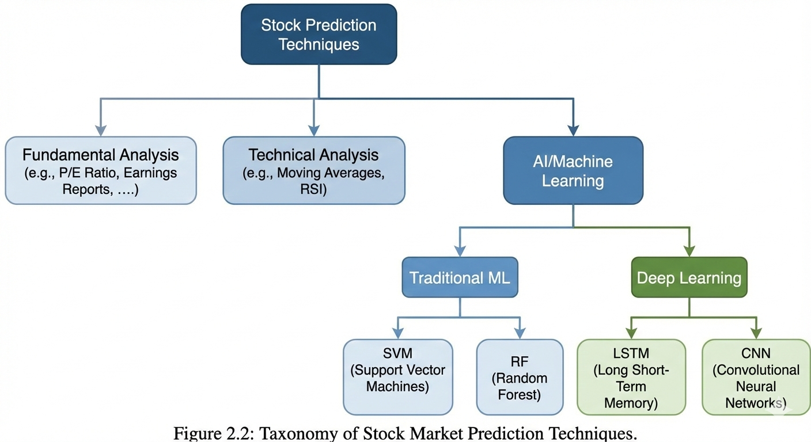
Figure 2.2: Taxonomy of Stock Market Prediction Techniques

Machine Learning and Deep Learning Models for Prediction
AI and ML methods are critical components in prediction due to their excellent learning capability when solving classification, regression and prediction problems (Nti et al., 2020).
- Deep Learning Models: LSTM networks are frequently used for stock price prediction due to their ability to capture long-term dependencies (Banoth & Yadala, 2024; Zepeng et al., 2025). Other network derivatives like Gated Recurrent Units (GRU) and Convolutional Neural Networks (CNN) are also employed (Jain & Vanzara, 2023).
- Ensemble Learning: Methods like Random Forest and XGBoost are very popular for predicting financial market trends (Jain & Vanzara, 2023; Theodorou et al., 2021). XGBoost shows great performance in predicting stock price changes, and also in classification (Jain & Vanzara, 2023).
- Hybrid Data Inputs: The lack of utilising simply past data is solved with a combination of structured (technical indicators like EMA, RSI, MACD, etc.) and unstructured (sentiment scores) data, which the research trends towards. Research provides clear evidence that a combination of text and market data improves the prediction accuracy (Cristescu et al., 2022; Jain & Vanzara, 2023). State-of-the-art models provide text features (sentiment score) and price data to a deep learning model as a pair of inputs. For example, Jin, Yang, & Liu (2020) provide ultimate evidence by progressively testing the models. Their baseline LSTM model achieved 60.12% accuracy; adding a sentiment index (S_LSTM) raised this to 65.73%; and their full hybrid model (S_EMDAM_LSTM) achieved 70.56% accuracy. This confirms that a multi-feature, hybrid approach is superior.

Review of Relevant Concepts
The AI-Driven Stock Investment Advisor relies on several complex technological concepts, especially within the field of Artificial Intelligence, which are important for processing complex financial information.

Machine Learning and Artificial Intelligence
Artificial intelligence is fundamentally transforming the financial services sector by providing personalised investment advice and allowing for portfolio management (Khadri & Reddy, 2024). AI leverages predictive analysis to analyse extensive financial data, reveal and identify patterns, and predict market movements (Jain & Vanzara, 2023).
Machine learning algorithms form the core of robo-advisors and other AI-driven platforms. ML techniques are used for data analysis, decision-making in financial management (Kashyap, 2025). The primary application of machine learning in the finance sector is predicting market trends and optimising asset allocation(Zepeng et al., 2025). Common ML models used in prediction and classification are :
- Support Vector Machines (SVM): These are used for prediction problems and are mostly used for unstable non-linear datasets (Hasselgren, Chrysoulas, Pitropakis, & Buchanan, 2023; Qi, 2025).
- Random Forest and Decision Trees: These are used for credit scoring and financial risk prediction (Masciari et al., 2024).
- Logistic Regression and Naïve Bayes Classifiers: These are traditional ML models which are used for data-driven classification and are effective when dealing with non-linear time series datasets (Masciari et al., 2024; Mehta, Pandya, & Kotecha, 2021).

Natural Language Processing and Sentiment Analysis
Natural Language Processing is a very important component for extracting insights from various amounts of unstructured textual data (Khadri & Reddy, 2024). Financial markets are always information-driven, allowing news to play a critical role in the shaping of investor expectations (Qi, 2025).
NLP allows the system to analyse financial news, earnings reports, social media sentiments and other data to provide a deeper understanding of market trends and investment insights (Pangavhane et al., 2023). NLP methods can classify and categorise text based on polarity (positive, negative, neutral). NLP methods can perform topic classification, irony detection based on the scale or level of data (Cristescu et al., 2022). The ability to process text, create and categorise tag words and extract information from unstructured data is the way sentiment analysis is performed(Shah et al., 2022).
Sentiment analysis is a primary application of Natural Language Processing, which is the process of categorising opinions in written text/language to determine the users’ attitude towards a particular topic or news (Gupta & Chen, 2020). Sentiment analysis is vital because investor sentiments derived from financial talks significantly interact with market volatility and returns (Qi, 2025).
Research on financial sentiment analysis has evolved through several methodological stages; It moves beyond the normal skeletal models to sophisticated AI-driven techniques (Qi, 2025). Historically, the field used to rely on lexicon-based approaches, and they used predefined sentiment dictionaries to assign polarity scores (Qi, 2025). Although these methods are easy to implement, they fail to grasp the financial terminology within financial documents. Deep learning, particularly Large Language Models (LLM's) like BERT and GPT, changed the course of financial sentiment analysis, providing an added boost and capabilities in contextual interpretation and semantic representation (Qi, 2025).
A comparative analysis was conducted by Shobayo et al. (2024) to evaluate the effectiveness of utilising advanced NLP techniques such as FinBERT and GPT-4 in contrast to Logistic Regression for sentiment analysis and stock index prediction on the data of Nigerian Exchange (NGX) All-Share Index and financial news. The results on NGX data indicated that sentiment data can be extracted from localised financial market sentiments. Despite this, the African stock market is gravely underrepresented in current literature; a bibliometric study only found 6 research papers regarding stock market social media sentiment localised to Africa, indicating a significant research gap in the African dataset (Nyakurukwa & Seetharam, 2023).

Deep Learning and Transformer models
Deep Learning (DL) refers to advanced AI methods that leverage neural networks with multiple hidden layers to capture complex patterns and representations within user preferences and item features (Masciari et al., 2024). DL models improve the efficiency and accuracy of recommender systems (Masciari et al., 2024).
Key DL models used in finance include;
- Long Short-Term Memory (LSTM) networks: These models are important in sequential recommendation models to capture long-term dependency within market data and are widely used for stock price prediction (Drus & Khalid, 2019; Puh & Bagić Babac, 2023).
- Convolutional Neural Networks: These are useful for tasks such as sentiment classification and feature extraction in complex NLP models (Jin, Yang, & Liu, 2020).
The Large Language Models (LLMs), for instance, BERT (Bidirectional Encoder Representations from Transformers) and GPT (Generative Pre-trained Transformer), have brought revolutionary changes in sentiment analysis, owing to their better contextual understanding and semantic representation when compared to traditional ML models (Qi, 2025).
Domain-specific LLMs are very useful in the finance domain, an example being:
- FinBERT: This LLM model is pre-trained and fine-tuned for the task of analysing financial texts(Araci, 2019; Qi, 2025). FinBERT is suitable for sentiment analysis and nuances in financial texts. FinBERT model helps in understanding minute sentiment shifts and subtle nuances in the context of financial texts, as presented in Figure. 2.3 (Puh & Bagić, 2023; Shobayo et al., 2024). Experimental studies have shown that domain-specific models, such as FinBERT, are better when it comes to extracting nuances of financial sentiments compared to general DL models and traditional ML approaches (Shobayo et al., 2024). Figure 2.3 shows the architectural details of the FinBERT model.
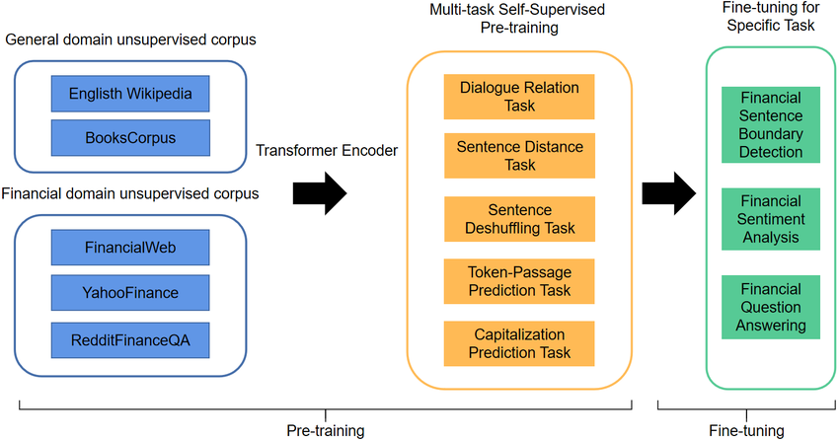
Figure 2.3: High-level Architecture of a FinBERT Model (J. Yang, Wang, & Li, 2022))

Review of Related Methods
The methods the AI-Driven Stock Investment Advisor utilises include sophisticated methods of extraction, combination and prediction of financial data. Primarily, they involve NLP and hybrid modelling approaches.

Sentiment Analysis Methodologies
In financial sentiment analysis, the research methodology has passed through three stages of progression:
- Lexicon-based approaches: They utilise a set of manually created lexicons, such as SentiWordNet and MPQA Subjectivity Lexicon, assigning polarity to text based on pre-defined word sentiment values. The simplicity of such approaches is the main advantage; however, they are domain-sensitive and unable to reflect specific domain language and context of financial texts.(Gupta & Chen, 2020; Nyakurukwa & Seetharam, 2023)
- Traditional Machine Learning models: Support Vector Machines(SVM) and Naive Bayes bring a data-driven classification approach to this field. However, they need to perform comprehensive feature engineering to get satisfactory results. (Qi, 2025). An accuracy of 80% of using LR with TF-IDF was achieved on StockTwits data (Gupta & Chen, 2020; Hasselgren et al., 2023).
- Deep Learning and Transformer Models: LSTMs and finally Transformer models, like BERT and FinBERT, use the power of pre-training on a large number of different texts and allow deep learning of semantics (Araci, 2019; Cristescu et al., 2022). Such generation has effectively solved limitations such as domain insensitivity and lack of semantic understanding in previous methods by extracting the relevant context from texts (Shobayo et al., 2024).

Hybrid and Multimodal Learning for Prediction
Hybrid learning means combining multiple data types, and is necessary for financial prediction in terms of improved predictive power and reliability (Qi, 2025). This approach is better than the single-source modelling approach.
Stock market prediction traditionally relies on historical data, which usually fails to capture sudden market shifts influenced by investor sentiment (Puh & Bagić, 2023). By integrating textual signals from financial news or sentiments with structured market data, such as trends, technical indicators, it significantly improves the accuracy of the prediction system (Qi, 2025).
In hybrid models used for prediction, sentiment variables are integrated alongside quantitative market indicators. (Qi, 2025). This unified feature set is used as the input for the predictive algorithms, such as LTSM. A study by Qi (2025) confirmed that incorporating sentiment variables enhances the forecasting accuracy by a mile and can be demonstrated by improvements in metrics like RMSE, MAE and R2.
Hybrid filtering is another approach used in hybrid recommendation systems (RSs), which combines at least two types of recommendation systems such as content-based and collaborative filtering to reduce the drawbacks of using each system independently and to provide customised recommendations (J Shah et al., 2022). Figure 2.4 shows how we can utilise hybrid learning and how the streams are fused.
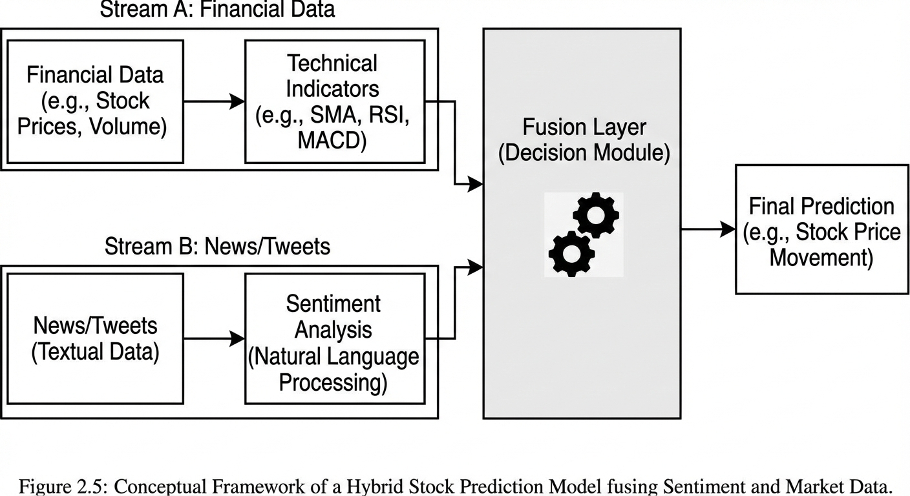
Figure 2.4: Hybrid Fusion Model

Predictive Modelling Techniques
For market prediction, different models are applied:
- Traditional Statistical Approaches, such as ARIMA (Autoregressive Integrated Moving Average), are used, but they are typically outperformed by AI methods (Puh & Bagić, 2023). ARIMA and models like it are primarily used for time series analysis and forecasting future trends; they assume that the time series data is stationary (Li et al., 2023; J Shah et al., 2022). ARIMA models are usually inaccurate when experiencing data instability (J Shah et al., 2022). For example, in comparative analyses of stock prediction models, ARIMA models often obtain much lower scores such as Mean Absolute Percentage Error (MAPE) between 7.39 and 7.98 compared to deep learning RNN models, which show that AI methods outperform ARIMA models (Li et al., 2023).
- Deep Learning Models, like LSTM, are effective for capturing the change over time in market data. Deep learning models are essential for handling sequential data and capturing long-term dependencies in the market. They excel because they leverage neural networks with multiple hidden layers to capture and get complex patterns and representations (Masciari et al., 2024). Hybrid deep learning frameworks like the FinBERT-LTSM model done by (Gu et al., 2024), combine FinBERT word embeddings (news sentiment analysis indicators) with historical stock price data into the LSTM architecture to predict outcomes and reduce errors (Gu et al., 2024).
LTSM models have been used to successfully predict the closing prices of major technological companies, including Apple (AAPL), Google (GOOG), and Microsoft Corporation (MSFT)(Li et al., 2023). In a study by Gu et al. (2024), the FinBERT-LSTM Architecture achieved the best performance with an accuracy of 0.955 and a low Mean Absolute Error of 173.67.
- Ensemble Learning: Ensemble learning algorithms combine multiple models to enhance predictive accuracy and robustness (Li et al., 2023). Algorithms such as Random Forest(RF) and XGBoost are highly effective for predicting when to buy/hold/sell and are also suitable for handling unstable and non-linear datasets (Asgarov, 2023; Theodorou et al., 2021). Ensemble methods are suitable for the final decision-making layer in financial systems. They can be used to train a lightweight fusion model that combines market trend analysis and sentiment scores.
- Neuro-Fuzzy Systems: Neuro-fuzzy systems are hybrid models designed to model certain and uncertain relationships (Asemi, Asemi, & Ko, 2025). Hybrid models like the Adaptive Neuro-Fuzzy Inference System (ANFIS) combine fuzzy logic (useful for incomplete or inaccurate data) and neural networks to model non-linear and uncertain relationships, providing reliable recommendations based on Key Decision Factors (KDFs) (Asemi et al., 2025). DecisionANFIS model uses the ANFIS hybrid system to provide investment suggestions. It takes 4 KDFs as input and then recommends an investment type of the output (Asemi et al., 2025).

Review of Existing Systems
The systems reviewed here demonstrate the abilities and limitations of existing financial recommendation and prediction platforms, and also highlight the gap addressed by a hybrid, localised advisor.

Decision Support Systems
These applications, such as alpha analysis programs, utilise the output of recommender systems to provide decision support services. They can be complex AI supercomputer frameworks such as IBM Watson or TensorFlow or simpler, custom-developed programs in Python/C++. The goal is to provide further analysis, such as extensive backtesting, beyond the initial recommendation (Vidler, 2024)
The major challenges they face are the data quality challenges, algorithmic transparency, the black box problem and regulatory compliance (Qi, 2025).

Hybrid and Sentiment-Driven Platform Support Systems
The systems that integrate various data sources for prediction also represent what the project builds on
- ASPENDYS: This is an interactive web platform designed to offer supportive information to investors. ASPENDYS addresses the gap of solely relying on historical data by combining both historical stock prices and extracted sentiment from social media (Twitter and StockTwits) and news websites (Theodorou et al., 2021). It uses NLP and Deep Learning technologies to generate investment signals through ML, sentiment analysis, and technical analysis components (Theodorou et al., 2021). Its main limitation for young Nigerians is the fact that it isn’t localised to Nigerians and is behind a very expensive paywall. Figure 2.5 shows the User interface (UI) of the ASPENDYS system.
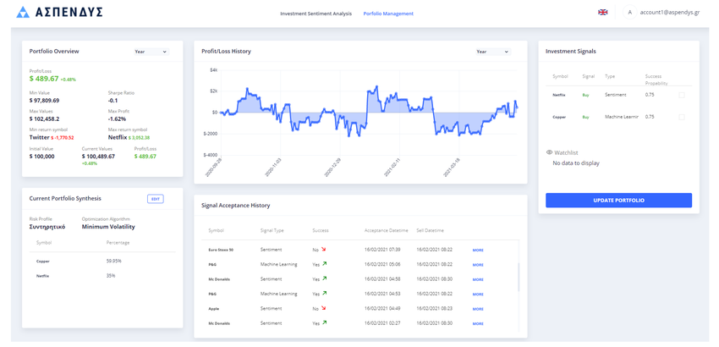
Figure 2.5: ASPENDYS ((Theodorou et al., 2021))
- Qlib: This is an AI-oriented Quantitative Investment Platform that integrates a high-performance data infrastructure with specialised ML tools for quantitative investment scenarios (Theodorou et al., 2021). We can see the structure and architecture of the Qlib model in Figure 2.6.
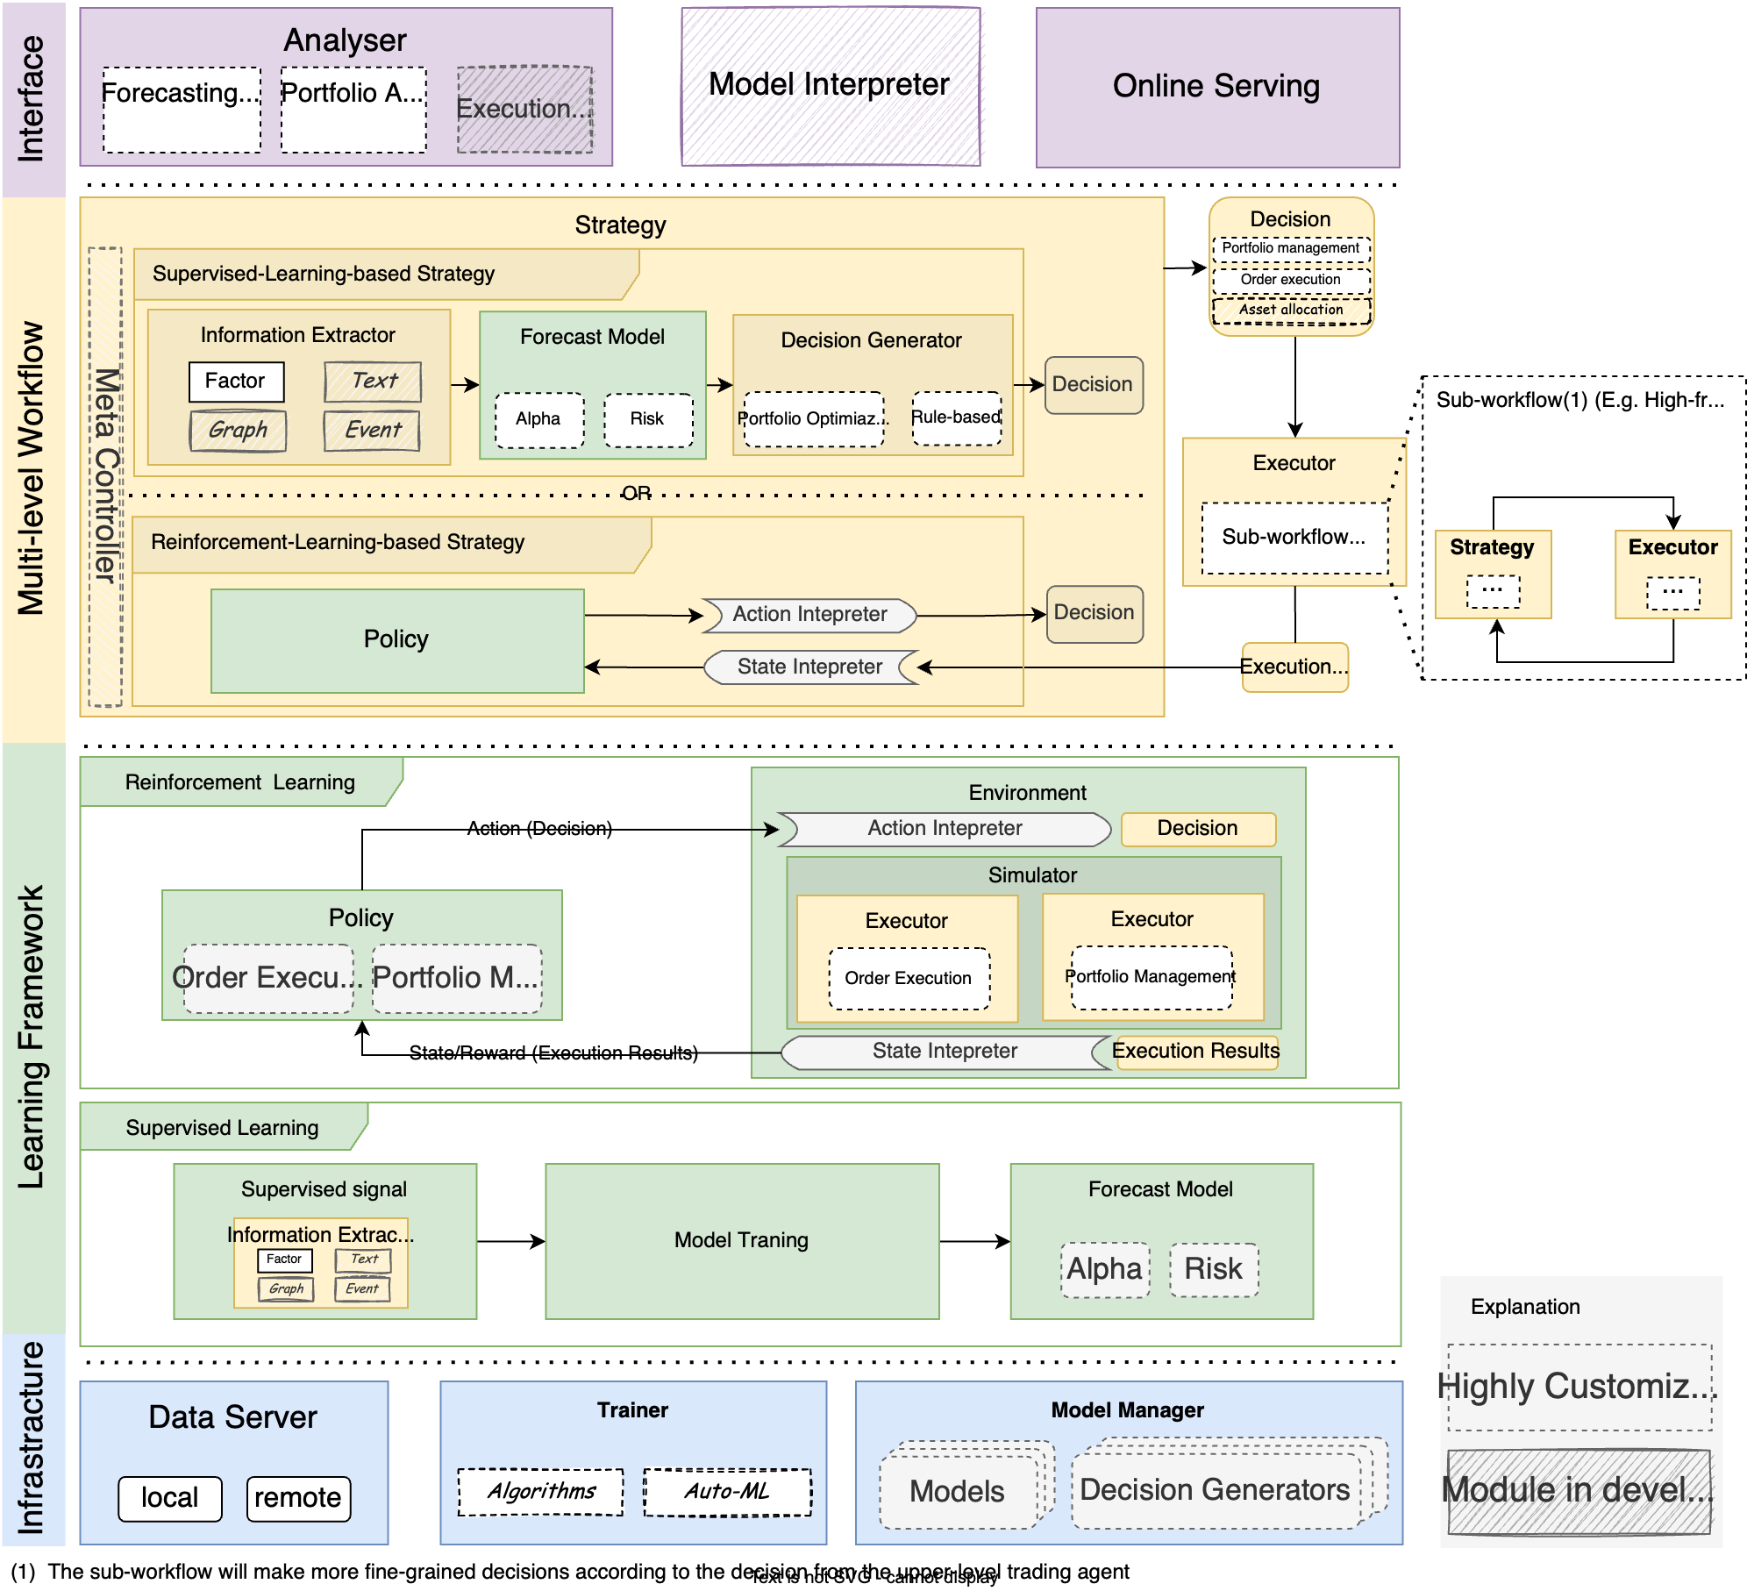
Figure 2.6: Qlib Model
(Source: https://www.threads.com/@quantscience_/post/DPy6_YxjXND/1-what-is-qlibqlib-is-an-open-source-ai-oriented-quantitative-investment-platfor)
- DecisionANFIS: This model represents an investment recommender system that utilises an Adaptive Neuro-Fuzzy Inference System (ANFIS), which is a hybrid of fuzzy logic and neural network, and aims to provide accurate and reliable recommendations based on Key Decision Factors (KDFs) (Asemi et al., 2025). This system is noted for its ability to handle incomplete or inaccurate data (Asemi et al., 2025).
- FinBERT-LSTM Frameworks: Academic studies have introduced advanced systems, such as the FinBERT-LSTM hybrid model, which embeds financial news sentiment via FinBERT and integrates this with historical price data into an LSTM network for enhanced predictive precision (Gu et al., 2024; Puh & Bagić, 2023). The workflow of an LSTM framework can be seen in Figure 2.7.
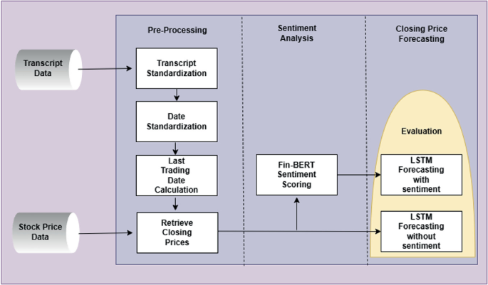
Figure 2.7 FinBERT LSTM Frameworks (Sarkar & Shahid, 2025)
Table 2.2: Comparison Table on Existing Systems and My System
S/N | System | Core Features & Methodology | Strengths | Limitations
 | ASPENDYS | It is an interactive web platform that combines historical prices with sentiment data from Twitter, StockTwits  It utilizes BERT model and Deep Learning to generate investment signals | It solves the problem of just relying on market data by integrating social and sentiment data. It also generates very distinct signals | It is not localized to the Nigerian market or the African market  It is also behind a very expensive paywall which makes it inaccessible to young and low capital investors
 | Qlib | It is an AI-oriented quantitative investment platform that uses high performance data with specialized machine learning tools for quantitative investments | It provides specialized tools for complex investment scenarios. | It is designed primarily for quantitative researchers and algorithmic trading, not for new and young retail investors.  It is also very complex without a user-centric simplified interface
 | DecisionANFIS | It is an investment recommender system that uses Adaptive Neuro-Fuzzy Inference System (ANFIS) which is a hybrid of fuzzy logic and neural networks.  It focuses on Key Decision Factors (KDFs) | It is excellent at handling incomplete or inaccurate data due to the nature of fuzzy logic. | It lacks real-world evaluation and is limited by the dataset size used for training.
 | FinBERT-LSTM Frameworks | It embeds financial news sentiment with FinBERT and integrates it with historical price data.  It also uses LSTM networks to capture long-term dependencies in the fused date. | It achieves state-of-the-art predictive precision with very high accuracy (95.5% accuracy) by fusing numerical and textual data. | It requires high computational requirement sometimes 110 minutes on GPU and makes it difficult to deploy for mobile use
 | My System | It is a mobile flutter dashboard and It utilises hybrid fusion of localised sentiment and technical indicators  It also uses FinBERT for sentiment + Ensemble Learning (XGBoost/RF) for classification and the Investment Safety Index. | It is specifically tailored to the Nigerian stock market.  It also uses a mobile first design which democratises access for young investors with low capital  It also provides a Safety Index (0-100) for proper explanation | The system hasn’t been tested at a large scale. The training data of the system is also very limited

Limitations of Generic Large Language Models
Large language models like GPT-5 can generate text and have powerful reasoning capabilities, but they can’t replicate the core function of the project. Their major limitations are:
- Functional Differences: Generic LLMs are not financial analytics engines, and they cannot perform the necessary steps of data collection, continuous analysis, fusion, scoring, visualisation, and real-time data-driven advising based on actual structured market data (Shobayo et al., 2024).
- Data Handling: LLMs primarily provide general financial insights in text but do not have the architecture to fuse structured (numerical) data from financial indicators with unstructured (textual) data from sentiment models to generate a unified investment score. (Shobayo et al., 2024).
- Performance Comparison: In comparison, LLM models performed modestly on a number of financial-related tasks when tested. While they sometimes struggle to generalise well on new, unseen data, indicating that Logistic Regression or FinBERT models are more predictive of the financial variable being examined (Shobayo et al., 2024).

The HybStockAdvisor System
The system is an AI-driven stock investment advisor for the Nigerian market, rather than a generic trading bot or static analysis. The system provides a decision support platform which seamlessly combines quantitative market data with qualitative public sentiment for truly context-specific investment advice. It is deployed on a loosely coupled cloud platform for responsiveness and scale with mobile clients in mind, and aims to provide simple, human-readable explanations for mathematical probabilities with the use of the Gemini 2.5 Flash model. The platform effectively democratises algorithmic trading for novice retail investors.

Core Features and Components
The hybrid architecture consists of three highly specific and separated intelligence layers: First, the localised data ingestion layer, which not only receives precise, quantitative information through financial interface but also simultaneously collects unstructured sentiment data from localised, or nationalistic forums such as Nairaland. Secondly, the qualitative sentiment module, which processes the slang of financial conversation with the use of Naija FinBERT and translates the text data to a strictly mathematical score with polarity. And finally, the quantitative market trends module, which calculates the values for technical indicators such as the Exponential Moving Average. Finally, all three modules will be fed into the prediction module and processed using the best algorithm from five models tested-a light GBM classifier-in order to produce easily interpretable and actionable market signals.
Dealing with the black box problem in finance has prompted the introduction of a proprietary Investment Safety Index. The score combines the machine learning model’s confidence, market volatilities and public sentiment’s stability into a single indicator value, so that users can view the risks in a readily understandable gauge by observing the gauge. Finally, the outputs are rendered on a live Flutter mobile dashboard featuring dynamic sparkline charts and clear investment recommendations. The dashboard is further enhanced by a conversational Gemini 2.5 Flash artificial intelligence copilot that provides instant educational context for every prediction

Addressing Identified Problems
The system directly addresses the issues outlined in the problem statement:
- Solving the lack of financial enterprise: The automation of the technical analysis and transformation of the complicated information to a simple Buy/Sell/Hold signal and a Safety Index will allow anyone without financial expertise to invest, therefore making the system easily accessible to young, inexperienced people.
- Providing Contextual Insight: This system combines sentiment analysis, unlike traditional brokers who would just display the price history. This gives the cause of price changes, like a price drop due to negative social sentiment vs. a market correction, the contextual information that is currently lacking in the existing platforms.
- Local Relevance: The system would primarily focus on Nigerian-specific tickers (GTCO, Dangote Cement) and can add US stocks later. The system would solve the problem of generic AI models, which do not find relevance to the local context of the African market.

Summary of Literature Review
The literature review proves that artificial intelligence through robo-advisors is changing financial market fundamentals through personalisation and efficiency. Sophisticated prediction beyond traditional approaches needs advanced AI techniques such as DL, ML and task-specific LLMs such as FinBERT. The main gap that exists is an AI system to fuse unstructured sentiment data and structured market factors locally and transparently, reliably and provide useful recommendations to young investors in Nigeria. This project directly fulfils this need with its hybrid model architecture, the local focus on Nigeria, providing a robust, data-driven decision engine.

‘

CHAPTER THREE

SYSTEM ANALYSIS AND DESIGN

Preamble
In this chapter, we discuss the system analysis and architecture design for the AI-driven stock investment advisor. We also describe its functional and non-functional requirements, the data gathering pipeline, the hybrid ML architecture and its cloud-based deployment plan. We will see that the system effectively integrates and harmonises the quantitative market information with public opinion information to provide an Investment Safety Index for the Nigerian Stock Exchange (NGX). This chapter includes system design, hybrid model architecture, dataset preparation, implementation process, UML modelling, and system evaluation strategy.
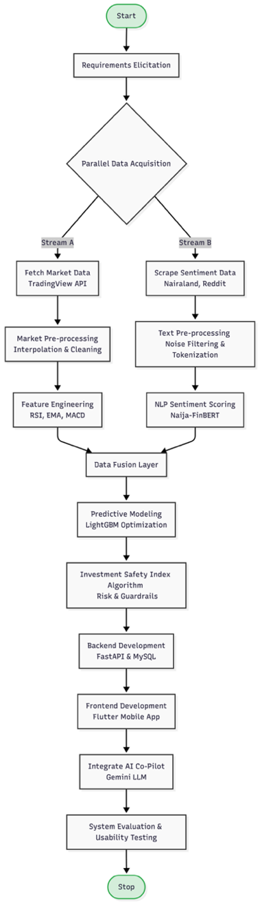
Figure 3.1:Project Workflow

Requirement Analysis
Requirements engineering involves the collection and documentation of the features required for the software system to function optimally and properly. Software requirements describe what the system should do and what the system shouldn’t do. The software requirements define the system boundaries, the constraints and the limitations of the system.

Functional Requirements
The functional requirements define the specific behaviours and feature the system must provide. They are detailed below;
- The system must securely authenticate users via a JWT-style tokenisation process and store user portfolios in a persistent database.
- The system must scrape live sentiment data from localised forums (Nairaland, Reddit) and calculate daily sentiment scores.
- The system must fetch live daily closing prices and compute technical indicators (RSI, EMA, MACD).
- The system must utilise a trained machine learning classification model to generate Buy, Hold, or Sell signals alongside a 0-100 Investment Safety Index.
- The system must feature a conversational AI assistant capable of contextualising the current stock’s metrics to provide readable explanations to the user.
- The system must include notifications to inform users of Buy, Hold and Sell signals

Non-Functional Requirements
The non-functional requirements define the constraints and performance metrics of the system. They are detailed below;
- The FastAPI backend must process data and return forecasts to the mobile client rapidly to ensure a seamless user experience.
- The cloud-hosted API and Aiven MySQL database must maintain high uptime to support daily market queries.
- The data pipeline must be capable of processing multiple NGX tickers simultaneously without data bleed or memory exhaustion.
- The core predictive model must be generalised across multiple sectors to prevent overfitting to a single asset.
- The Flutter mobile interface must be intuitive, accessible and easy for young retail investors to understand.

System Architecture
The entire architecture of the HybStockAdvisor platform has been developed based on a decoupled, cloud-first multi-modal architecture which deals with streams of heterogenous data concurrently. Conventional financial applications run solely on isolated technical charting or generic global news feeds that leads to a gap for emerging local markets like the Nigerian Stock Exchange (NGX)(J Shah et al., 2022). This architecture aims to avoid the pitfall by segregating the system into a fast quantitative pipeline and a domain-based qualitative pipeline. These distinct streams are ingested, cleaned, and structurally fused within a cloud computing environment before being processed by the ensemble learning layer.(Theodorou et al., 2021) The resulting actionable metrics are then securely delivered to the user interface via an asynchronous application programming interface (API) hosted on a United States-based cloud infrastructure. To eliminate the issue of zero or cold-start latency and achieve high availability, the FastAPI backend as well as the ML pipeline were deployed to an already initialized and continuously active instance in a cloud service. This means the system is always in an active production-readiness state which means live streams of concurrently incoming requests can be handled during live trading hours without any speed constraint as experienced in shared environments. This entire architectural plan of the data pipeline and workflow has been formalized in Figure 3.2:
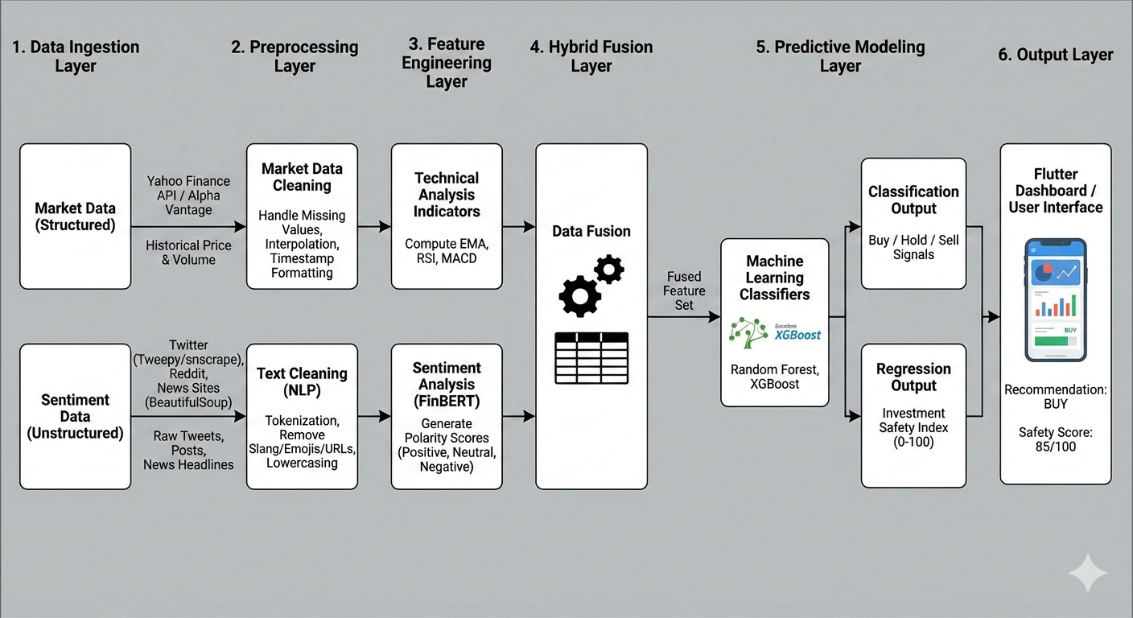
Figure 3.2:Project Methodology

Multi-Source Data Ingestion Layer
Multi-source data ingestion layer-This layer represents the "sensory" component of the system that takes in real-time market dynamics and free-form public discussion of finance. Quantitative market data is acquired by programmatically querying the TradingView API, which gives the OHLC history at an atomic level with volumes on a daily basis. Simultaneously, qualitative ingestion engines utilise parallelised web scraping programs to extract consumer text from localised, retail investing forums(Drus & Khalid, 2019). This involves systematic, custom crawlers scanning investment threads on Nairaland and financial subreddits on Reddit to obtain rough, unfiltered user text. Through this collection of both market tickers and public forums, the ingestion layer builds up a "ground truth" dataset across different dimensions (Hasselgren et al., 2023).

The Sentiment Data Pipeline
After the raw text information is scraped by the ingestion layer it is then sent directly to the automatic sentiment data processing to be purified in terms of quality. Raw web data usually contains substantial amounts of junk text such as: hyper-linked web addresses, formatting markup, unnecessary chit chat, etc which needs to be cleaned out of the data set with custom made regex's. After the raw data is initially cleansed, the leftover data is then put through a custom made Nigerian Financial Lexicon in order to make sure non-economic discussions occurring in forum post are discarded from the set of data that enters the model. The separated financial discussions are then fed directly into the finetuned Naija-FinBERT Natural Language Processing (NLP) model, the latter of which uses context to analyse the local dialogue, and translate the colloquial data into concrete numerical values denoting polarity with ranging scores from -1.0 (Highly Bearish) to +1.0 (Highly Bullish) (Araci, 2019; Shobayo et al., 2024)

The Market Data Pipeline
While sentiment is being analysed, the quantitative pricing information is passed through a separate market data processing pipeline and relevant technical predictors are generated. Market data time series are generally incomplete because the market is closed for weekends and national holidays. Linear interpolation is applied to the time series to generate uninterrupted mathematical lines between subsequent market periods, thus maintaining the structure of data for machine learning models(Li et al., 2023). After generating a continuous time series, more sophisticated technical indicators like the Relative Strength Index (RSI), Exponential Moving Averages (EMA_50 and EMA_200), and Moving Average Convergence Divergence (MACD) are generated through the Pandas-TA algorithmic library. It is important to note that technical components are generated using localised grouping functions, so moving averages only occur between a single equity's historical data time series; there is no across-company data pollution (Asgarov, 2023).

The Feature Fusion Layer
The feature fusion layer represents a crucial juncture where human qualitative understanding and automated market monitoring merge into one cohesive matrix. As sentiment data arises as a haphazard event-series while price action operates as a definitive daily time-series, a routine called time-based synchronisation must synchronise the data (Jin et al., 2020). Average daily FinBERT sentiment is concatenated to the created technical indicator vector at this layer. An exact match on the date and ticker identifier is used to ensure this data alignment. A constructed, scientifically-grounded zero score will be used if there are any days that were publicly silent in order to ensure continuity of the vector. Concatenating data points in this structured manner converts separate arrays of data into an 11,556-length historical multi-modal data vector, completely preparing the data set for complex pattern detection (Banoth & Yadala, 2024).

The Machine Learning Prediction Layer
Hybridised feature vectors are fed from the fusion layer to the machine learning prediction layer to predict price direction. The engine is an optimised LightGBM classifier. It was selected due to its leaf-wise tree growing strategy, suitable for capturing complex relationships present in table data(J Shah et al., 2022). This is a binary classifier which will use a combination of historical technical factors and the live sentiment score to produce a probability for how likely the equity is to increase in value in the following market session (Khan et al., 2022). Since class imbalance will result in very limited chances of financial profit from trading in the majority class, the weights are deliberately biased. This leads to a robust and well-calibrated measure of probability to estimate upward market momentum.

The Recommendation Layer (Safety Index Engine)
The underlying classification probabilities from the machine learning core are immediately piped into the recommendation layer to create a synthesised, investor-friendly advisory metric. Instead of displaying confusing and unpredictable statistical probabilities to novice investors, the recommendation layer applies a proprietary multi-factor algorithm to derive a predictable and less volatile 0-100 Investment Safety Index. The structural composition of this scoring algorithm can be characterised by the following mathematical equation:
S = (0.5 x P_{AI}) + (0.3 x M_{Stab}) + (0.2 x Sentiment)
Where:
- P_{AI} is the probability output from the optimised LightGBM model (scaled 0-100).
- M_{Stab} is market stability derived from the RSI (100 - |RSI - 50| x 2) and penalises extreme volatility.
- Normalised Sentiment Sentiment Score (0-100) as provided by the FinBERT NLP engine.
In an effort to ensure robust risk prevention, an absolute financial guardrails protocol is enforced at the recommendation layer, which can override the AI-driven signal if absolute danger points of volatility are met. A prime example is if a stock has become dangerously overbought with an RSI greater than 70, then a draconian point deduction will be taken by the algorithm to protect retail capital from a bubble (Vidler, 2024).

Table 3.1: Investment Safety Index Weighting Formula
Metric Component | Data Source | Assigned Weight | Purpose
AI Confidence | LightGBM Output | 50% | Primary predictive driver for directional momentum.
Market Stability | 14-Day RSI | 30% | Acts as a mathematical guardrail against extreme volatility.
Public Sentiment | Naija FinBERT | 20% | Captures retail investor psychology and emotional market shifts.

The Dashboard Output Layer
The last layer of the architecture is the dashboard output layer. Its function is to aggregate the metrics from the system and draw them into the client. These calculated Safety Index value, market charts generated and the recommendation strings is bundled in lightweight JSON and are consumed by the cloud-based FastAPI backend. This private cloud instance communicates to the cross-platform Flutter mobile client through the non-blocking REST-based APIs (Pangavhane et al., 2023). The incoming data is parsed by the Flutter application, and then dynamically high-fidelity, historical sparklines and responsive circular gauges are drawn. Further, a natural context injection module pipes the incoming stock metrics to a Gemini Large Language Model, and an on-demand conversational co-pilot gives explanations to the resultant investment signal from the system in a natural language format(George, 2024).

Dataset Description and Preprocessing
One of the key pillars upon which any strong machine learning architecture stands is based on the quality, structure, and soundness of the underlying training data. For this work, the process of formulating the training data was designed to encompass both the quantitative market movements and the behavioural sentiment of retail investors toward Nigerian Stock Exchange (NGX) financial instruments, and public discourse(Nti et al., 2020). In an inherently noisy and volatile market like an emerging financial market, using one data modality could over-fit the model or not perform well when deployed on the live market (Jain & Vanzara, 2023). Therefore, a complex hybrid dataset was constructed in chronological order based on structured price action and unstructured public discourse. Detailed below are the comprehensive methods undertaken in sourcing, structuring, cleaning, and mathematically transforming the raw data into a usable format for the LightGBM prediction engine.

Dataset Sources
Historical market data was retrieved from five different, high-liquidity Nigerian Stock Exchange (NGX) equities over 7 years, from 2019 to 2026, to train a generalised model that could grasp market trends worldwide. These equities to train the artificial intelligence over different market magnitudes are Guaranty Trust Holding Company (GTCO), Zenith Bank, Dangote Cement, MTN Nigeria and WAPCO, respectively. Due to inconsistent coverage of the African market via traditional international finance APIs (Yahoo Finance/Alpha Vantage), raw quantitative historical prices were retrieved and checked against Investing.com and TradingView's platforms to check the structural validity of price histories. Simultaneously, qualitative sentiment data was retrieved directly from local Nigerian online communities to harness local retail investors' authentic psychology, momentum (Haritha & Sahana, 2023). Web scrapers were used to systematically collect unstructured financial commentary on the investment boards of Nairaland, several Nigerian subreddits on Reddit and mock-ups of social media(Mehta et al., 2021).

Dataset Structure
Initially, the baseline global training data set was a multi-dimensional flat file made up of combined historical data and local sentiment scores. This flat file structure was ordered chronologically by day and grouped by unique equity ticker to prevent information bleed between stocks. The initial quantitative columns of the flat file included daily vectors of open, high, low and close prices as well as daily trading volume. These values are the foundation upon which the subsequent technical analysis features are based. Also included in the raw data set was a continuous column representing the daily summed FinBERT polarity scores. This initial raw structure is provided in Table 3.1.
Table 3.2: Raw Dataset Structure
Feature Name | Data Type | Description
Date | Datetime | Trading session date
Close | Float | Final closing price (₦)
Open | Float | Initial opening price (₦)
High | Float | Highest price of the session
Low | Float | Lowest price of the session
Volume | Integer | Total shares traded
Ticker | String | Unique company identifier
Avg_Sentiment | Float | FinBERT polarity score (-1 to 1)

After its initial generation, the dataset was mathematically pre-processed to extract complex features necessary for predictive analysis. Using computation libraries, pure technical indicators were computed directly from the vectors of price. These resulted in the final processed dataset including fourteen-day Relative Strength Indexes, Exponential Moving Averages, and Moving Average Convergence Divergence data, which was fed to the machine learning classifier. Lastly, the target column was created, which defined the classification: whether the future close price resulted in a profitable uplift in price. The table showing the final format of the data used by the machine learning classifier is displayed in Table 3.2.
Table 3.3: Processed Dataset Feature Matrix
Engineered Feature | Algorithmic Purpose
RSI | Measures momentum and overbought/oversold conditions (14-day window).
EMA_50 | Tracks short-to-medium term price momentum (50-day window).
EMA_200 | Establishes the long-term macroeconomic trend (200-day window).
MACD_12_26_9 | Identifies trend direction and momentum shifts.
Bollinger Bands | Measures extreme market volatility (Upper, Lower, Middle bands).
Target | Binary classification objective (1 = Price Increase, 0 = Price Decrease).

Preprocessing Techniques
Raw financial and textual datasets arrive at the pipeline as flawed streams and require a huge algorithm pre-processing before they can be safely fed into the predictive models. Firstly, to counter the missing numerical values because of weekends and public holidays, linear interpolation has been used to draw a mathematically continuous line between trading sessions. Secondly, in order to create high-quality technical indicator features like RSI, 50-day EMA and MACD using Pandas-TA, rigid grouping functions were employed to independently compute the value for every distinct ticker. Thirdly, qualitatively, free text in the forum was thoroughly cleaned of noise by Regular Expressions (Regex) to remove noisy HTML tags, hyperlinks and non-alphanumeric data from the corpus. Fourthly, after textual inputs had been cleaned up, the input strings were fed into a HuggingFace tokeniser to transform them from localised Nigerian financial keywords to padded numerical tensors usable for the FinBERT architecture (Sarkar & Shahid, 2025). Lastly, to ensure uniformity across various price ranges (e.g., a high price share value of MTN and a much lower price share value of Zenith), normalisation was incorporated into the learning pipeline, and the lightGBM gradient descent process was stabilised.

Hybrid Model Architecture
The core architectural foundation of this study is that a hybrid machine learning architecture is used, which mathematically combines the qualitative world of behavioural economics with the quantitative domain of technical analysis. Historically, algorithmic trading has been dominated by systems that only look at mathematical price derivatives while entirely disregarding psychological momentum induced by individual retail traders in their respective locality (Valencia, Gómez-Espinosa, & Valdés-Aguirre, 2019). Conversely, pure sentiment-driven systems fail to account for key levels of support and resistance, resulting in improper market entries(Puh & Bagić, 2023). Both of these methods suffer from their individual limitations, which this system seeks to address by implementing a double-branch hybrid architecture. This architecture works by feeding a tailored natural language processing model and sophisticated gradient boosting classifier through two parallel branches of a machine learning architecture, effectively mandating that the system considers public emotion and stock price truth prior to making an eventual call. Figure 3.3. is a visual representation of this hybrid interaction.
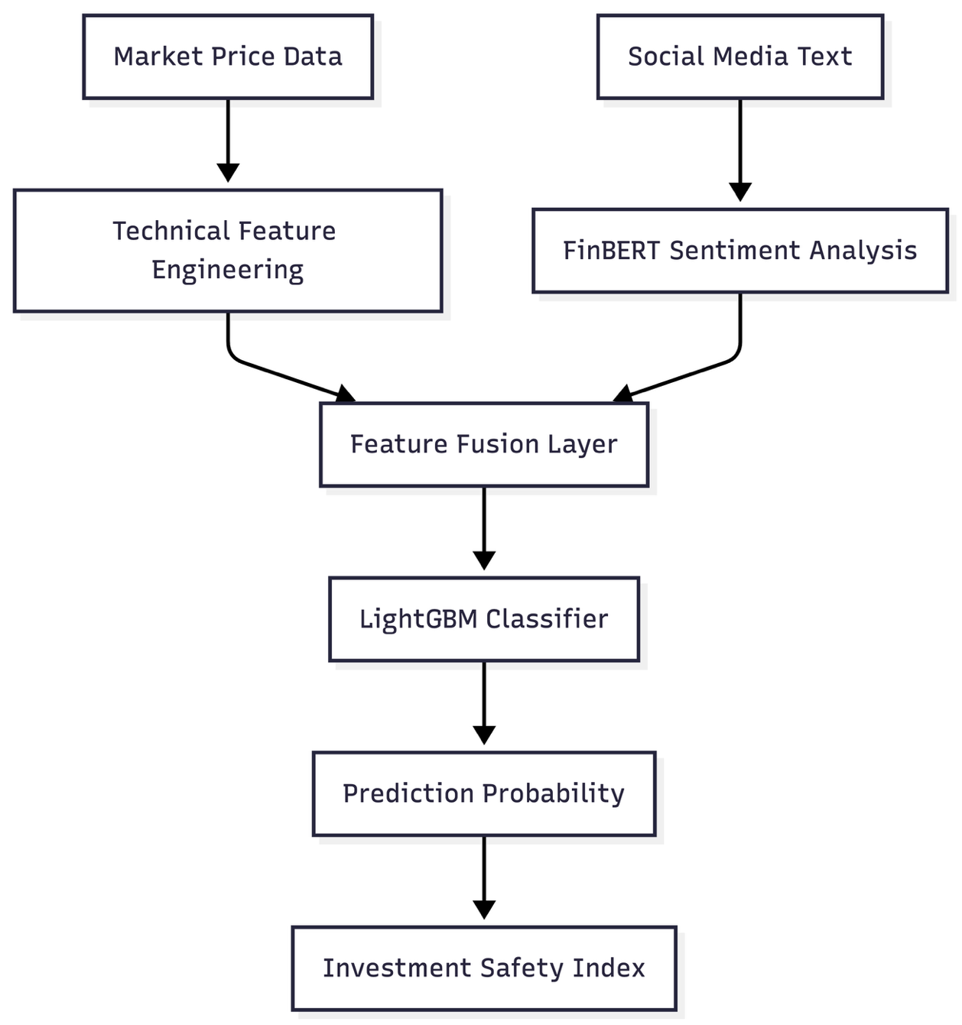
Figure 3.3: The structural flow of the Hybrid Model Architecture.

The Natural Language Processing Branch (Naija-FinBERT)
The qualitative branch of the hybrid architecture is driven by a specialised adaptation of the Financial Bidirectional Encoder Representations from Transformers (FinBERT) model (Araci, 2019). Standard sentiment models trained exclusively on Wall Street lexicons or global financial news consistently struggle to interpret the localised colloquialisms, abbreviations, and unique slang utilised by Nigerian retail investors. The original FinBERT base model was then adapted for this domain adaptation task by fine-tuning it with a custom corpus of localised Nigerian stock market comments scraped from forums such as Nairaland(Gu et al., 2024). The Naija-FinBERT model then works by feeding the cleansed daily text through the various attention layers to calculate the context-specific semantic polarity of the discussion. The model concludes its inference by categorising the text into explicit probability scores for Negative, Neutral, and Positive sentiment, which are then mathematically compressed into a single continuous numerical feature scaled from -1.0 to +1.0.

The Predictive Classification Branch (LightGBM)
LightGBM is the foundation of the quantitative arm of the architecture; we chose it because of its advanced nature with respect to the execution time and accuracy on tabular financial data (J Shah et al., 2022) as it doesn't follow a standard level-wise growth that characterizes traditional tree based algorithms such as Random Forest, but follows a leaf-wise growth so the analysis of the non-linear and complex patterns within the financial time series becomes quicker. The aim of this classifier is simple and fixed: if future closing price > current closing price, return 1 (Buy Signal), else return 0 (Sell/Hold Signal). This conclusion is derived from the inputs given to the LightGBM classifier, which are the technical indicators that we created, such as the 14-day RSI, the 50-day EMA, etc., which it analyses among thousands of randomised decision trees to return a probability percentage indicating the probability of an upward trend on the market with no level of uncertainty (Iyyappan et al., 2022).

Feature Integration and Fusion Strategy
The strength of this architecture as a predictive system really comes in the method used to integrate these two (NLP and Classification) branches of the model (J Shah et al., 2022). "Early Fusion" is used for this model, treating the qualitative score of sentiment as an independent numerical feature and feeding that directly into the quantitative feature set before final classification. By feeding the FinBERT output of a positive/negative score of 1.0/-1.0 as another numerical feature column alongside the technical indicators RSI and EMA, LightGBM can consider the influence of public sentiment directly against purely quantitative technical indicators. If the sentiment is very high positive, but the RSI technical indicator has reached an extremely overbought level, the decision trees can learn to trust the technical constraint and discard the influence of the excited chatter.

Model Development and Training
During this phase, we focused on developing the predictive ability of the stock advisory system. The chaotic nature and quick paradigm changes inherent in financial markets mean that algorithmic architectures must be rigorously tested empirically. The goal of this phase was to develop a classification engine which could identify profitable Buy signals whilst attempting to minimise False Positive signals, potentially resulting in considerable loss of capital for retail investors. To this end, a rigorous comparative analysis of classical statistical baselines and cutting-edge ensemble approaches was undertaken. In the subsequent sections, we cover how the algorithms were selected, the particular methodology to train and validate them and the empirical results that ultimately led to the choice of architecture.

Algorithms Used
Five diverse machine learning algorithms were selected for experimentation. A blend of established statistical methods and modern ensemble techniques was chosen to perform the comparison in a scientific way:
- Logistic Regression: Chose to run a linear model as a statistical baseline to showcase that a more sophisticated model was necessary (Shobayo et al., 2024).
- AdaBoost (Adaptive Boosting): An ensemble technique that incrementally weights each classification based on the previous model's errors, which serves as a 'bridge' between classical statistical and advanced gradient boosting models(J Shah et al., 2022).
- Random Forest: A bagging ensemble approach which creates a large number of decision trees that are combined to produce the final output, considered very effective at reducing over-fitting in noisy datasets(J Shah et al., 2022).
- XGBoost (Extreme Gradient Boosting): An optimisation of gradient boosting that typically records the highest predictive accuracy with rapid execution time in financial modelling literature (J Shah et al., 2022).
- LightGBM (Light Gradient Boosting Machine): Chosen as our final champion architecture, the leaf-wise growth that LightGBM employ helps it isolate highly complex and non-linear financial patterns efficiently.
Table 3.4: Evaluated Machine Learning Classifiers
Algorithm Name | Model Type | Core Mechanism | Selection Rationale
Logistic Regression | Statistical | Linear probability estimation | Established baseline benchmark
AdaBoost | Ensemble | Sequential error correction | High resistance to overfitting
Random Forest | Ensemble | Bagged decision trees | Handles non-linear financial data
XGBoost | Ensemble | Level-wise gradient boosting | High execution speed and accuracy
LightGBM | Ensemble | Leaf-wise gradient boosting | Superior complex pattern recognition

Training Process and Configuration
The training technique used was carefully designed to suit the complicated issues that plague financial time series forecasting (Jain & Vanzara, 2023). Firstly, "look-ahead bias" (when a model accidentally uses future information) was completely avoided by using a rigid, Time-Series Split. Only the first 80% of the past timeline was available to train the models with, the rest being entirely excluded from training until testing. Secondly, the models needed to learn to overcome the severe class imbalance of profitable "Buy" signals, compared to non-profitable markets, using a dynamic scaleposweight parameter to heavily penalise failure in seeking the minority class. Lastly, to best suit the predictive abilities of each algorithm, RandomizedSearchCV was employed to try hundreds of combinations of hyperparameters in order to find the best ones.

Model Output and Justification
These aren't outputs of the trained classification models as a strict string, rather as a decimal probability (Vidler, 2024). In particular, the LightGBM framework calculates a specific percentage of how likely the price will increase in the next trading session, based on the concatenated matrix of technical indicators and sentiment scores. This is the numerical basis of calculating the overall 0-100 Investment Safety Index. The justification for choosing LightGBM over the others is described explicitly below in Table 3.2 where we find LightGBM to be significantly better at picking up movements in the market. Although both Random Forest and XGBoost give reasonable base accuracy, LightGBM provided the highest F1-Score (0.6099) in detecting up-trends at the expense of none for its recall rate (1.0000).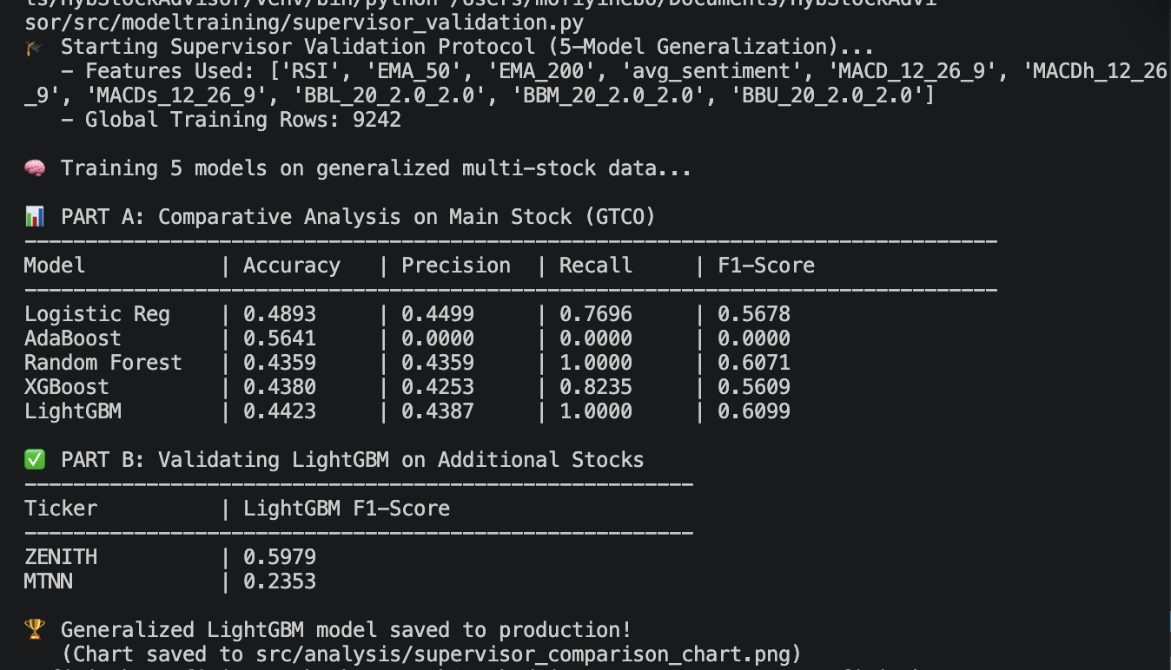
Figure 3.4: Performance and comparative analysis of the 5 models

System Evaluation Strategy
It is important to perform a multi-dimensional analysis to determine the practicability of machine learning models within a financial context, such as the machine learning model tested in the financial application above. It is particularly misleading to only evaluate based on one measure alone in financial applications, due to the inherently volatile market of the Nigerian Stock Exchange. The evaluation framework has thus been constructed to adequately test the ability of the AI to predict and the capability of the software system to function, in terms of the measures of the mathematical model, technical performance of the system, and backtesting simulation in the stock market. This is because by evaluating the system on multiple fronts, a more practical solution can be delivered to the retail investors.

Model Evaluation Metrics
To adequately assess the predictive power of the LightGBM classifier, a comprehensive matrix of statistical performance indicators was deployed. Accuracy alone is by definition inadequate in the field of financial forecasting, as profit-making days are few and far between compared to losses, given the highly imbalanced nature of the class distribution. Therefore, the F1-Score was treated as the leading performance metric as it is the harmonic mean between precision and recall; precision was observed to determine the percentage of 'Buy' signals predicted that were profitable and hence provide a level of safety to users from incorrect entries into the market, while recall was observed to assess how well the model picks out correct rallies. The Confusion Matrix was produced in order to show exactly how many true positives, true negatives, false positives, and false negatives are obtained with the model.

System Performance Metrics
The effectiveness of this platform doesn't depend just on the fact that the AI is correct or not; it also depends on its real-time usage. The retail investor will need real-time insight at real time. Significant delay in processing will render the system useless. To ensure this is the case, strict performance tracking was used on the FastAPI backend in order to get the actual time of the API response while receiving concurrent calls. Similarly, prediction latency was strictly monitored to get the millisecond time delay between pulling live data from TradingView and calculating the final LightGBM probability. The Flutter frontend was client-side tested to determine loading times, ensuring that interactive components like sparklines and the Safety Index gauge didn't become unresponsive and freeze users' devices.

Live Execution Evaluation
In order to substantiate that an algorithmic trading platform will, in fact, be consistently reliable and profitable, we must empirically test our theoretical framework vigorously in live market conditions. To assess the true financial accuracy of the LightGBM algorithm against the genuine real-time movements in prices, a live forward testing structure was developed. This differed from our previous simulation framework in that actual funds were deployed for live testing and used to invest in those selected stocks scoring high for their Investment Safety Index. Live data was passed to the system that would actively send a buy order in order to establish the precise, ultimate profit and loss margin for the stipulated time period.
Figure 3.5: Model Evaluation Workflow showing the flow from training to metrics output.

UML Modelling
Unified Modelling Language (UML) diagrams were used to visually represent the structural design, behavioural flow, and the interface boundaries of the cloud-based application. The Use Case diagram shows the main boundaries of the functional requirements and how specifically the young retail investor will interact with the AI Co-Pilot and the Watchlist. The Activity diagram shows how the above user actions are executed sequentially, showing the path from the initial login screen to the stock selection and final dashboard screen. To map out the technical communication between the parts of the system, a Sequence diagram was implemented to show the specific API call that the Flutter client will send to the FastAPI backend. The sequence will clearly show how the prediction probability is produced by the LightGBM model, how it is packaged and returned as a JSON object to the front-end for presentation.
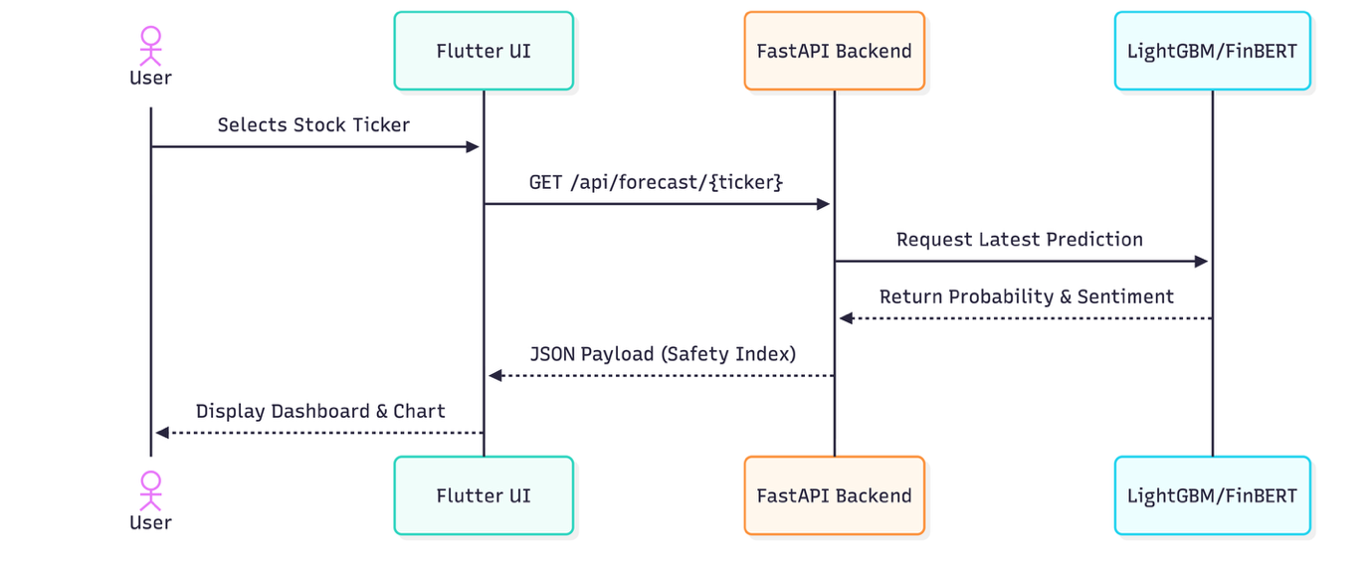
Figure 3.6: Sequence Diagram showing the flow between User, API, Model, and Response lifecycle.

Use Case Diagram
The use case diagram includes two actors: the Young Investor and the Cloud System.
- The investor can: Register/Login, Search NGX Stock, View the Investment Safety Index, Add a stock to your watchlist and portfolio and Chat with the AI Co-Pilot.
- The System can: Fetch daily prices, scrape social media, compute AI predictions, and update the database.

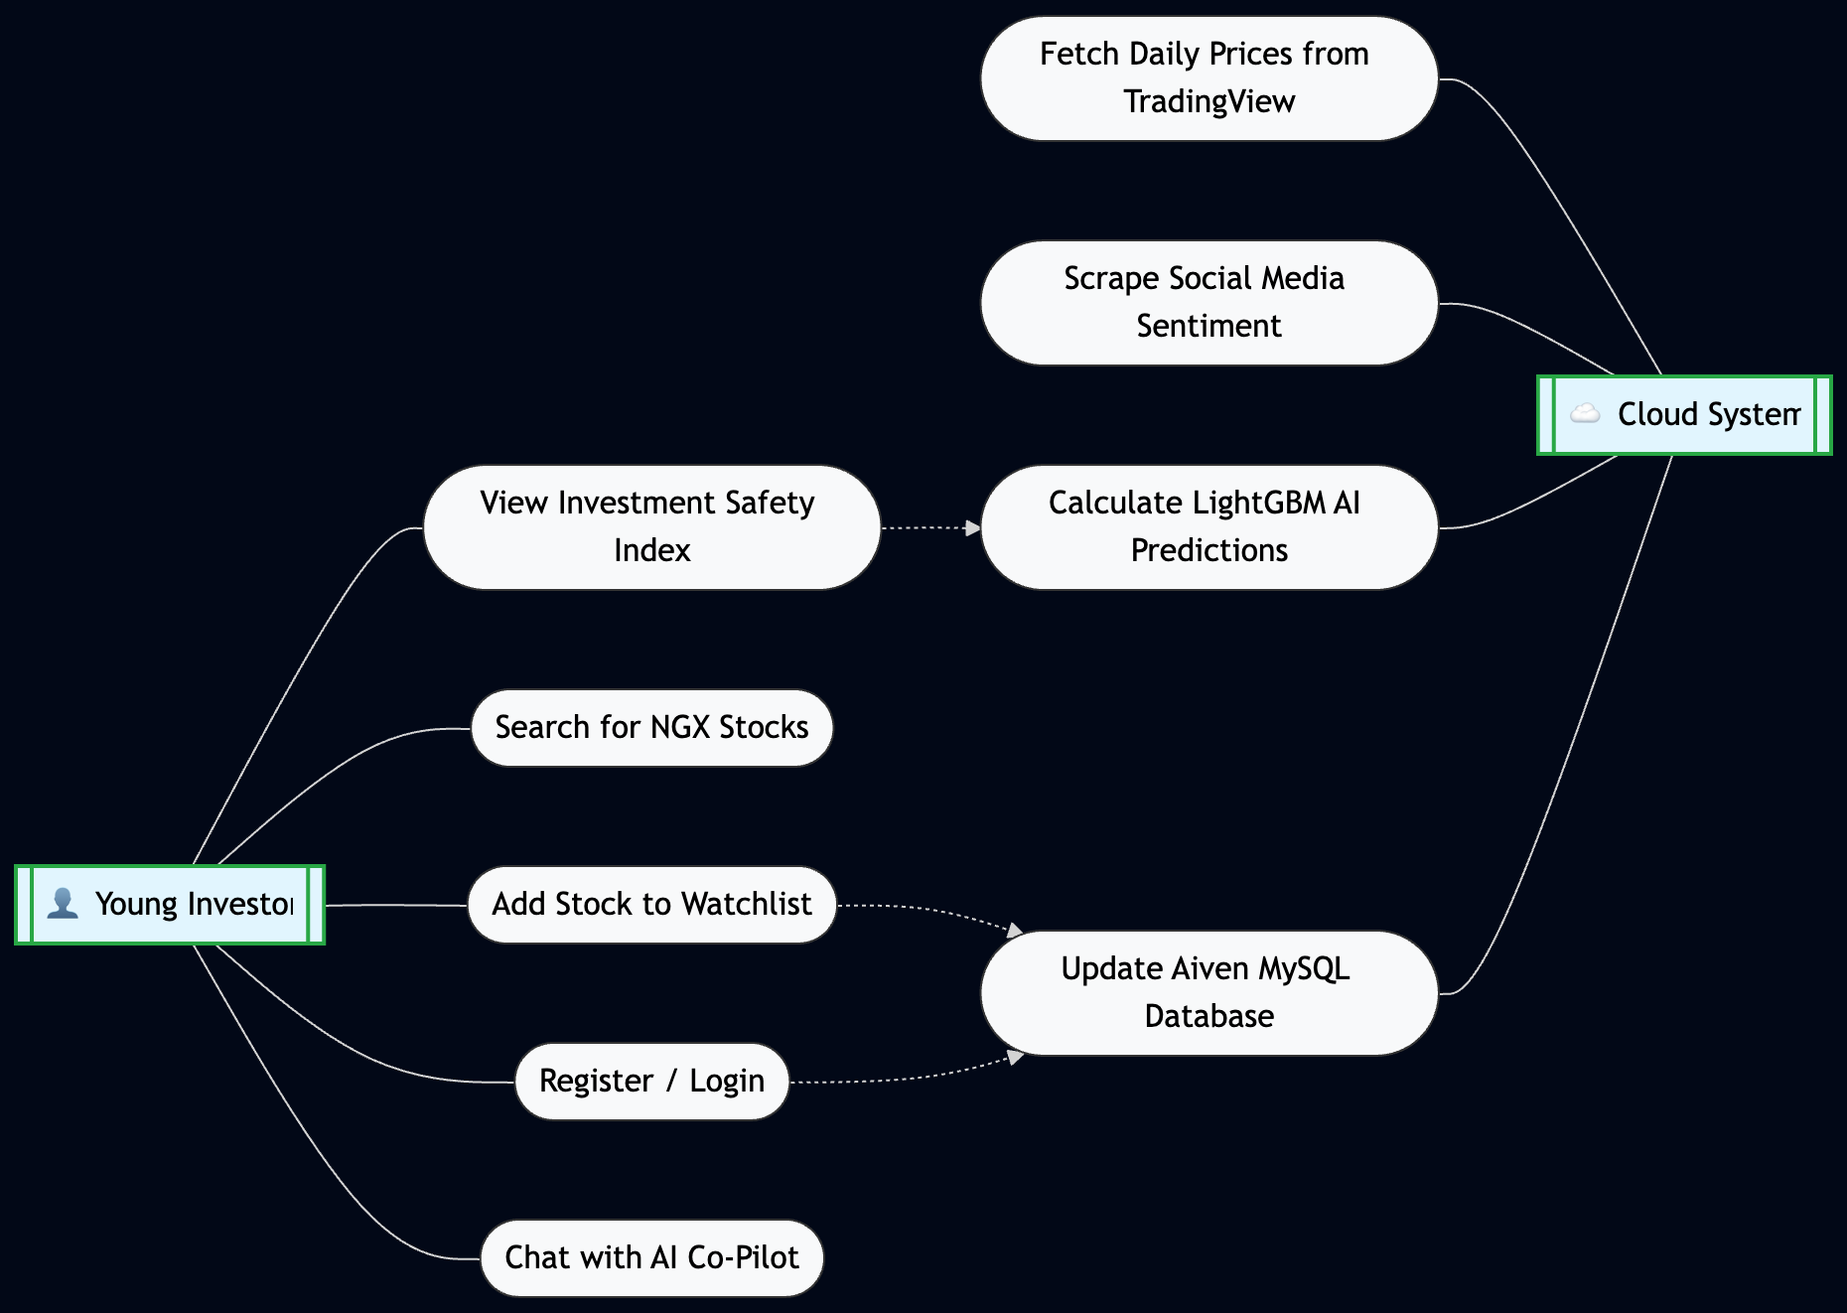
Figure 3.7: Use Case Diagram

Activity Diagram
The Activity diagram shows the workflow:
- User logs into the Flutter App.
- User selects a stock ticker from the dashboard.
- The App sends an API request to the FastAPI Backend.
- The Backend queries the pre-calculated SAFETY_INDEX dataset.
- The data is returned to the App.
- The App displays the sparkline chart and the Buy/Hold/Sell recommendation.
- (Optional flow) User opens the Chatbot -> App injects current metrics -> Gemini API returns the explanation.
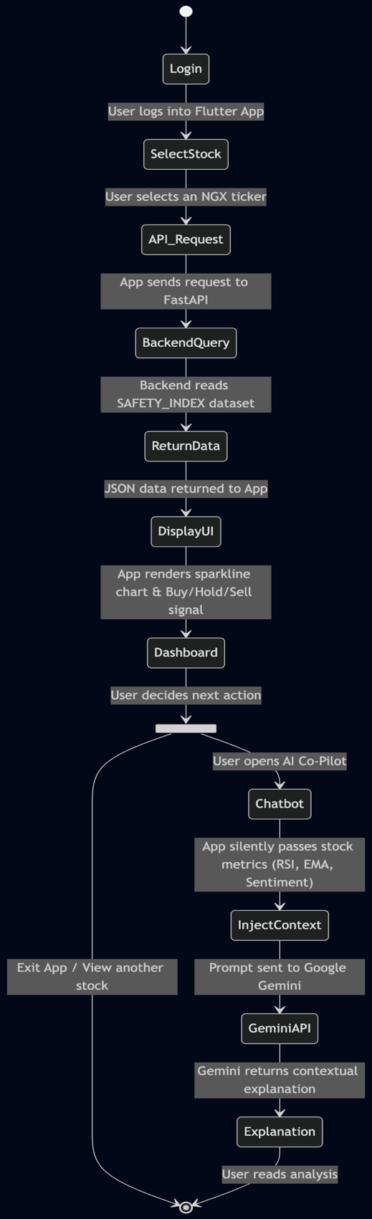
Figure 3.8: Project Walkthrough Diagram

System Implementation Flow
The actual implementation for the HybStockAdvisor involves the use of a high-volume, automatic, linear pipe which has been written to be able to be deployed on a daily basis to the cloud. The process begins at the point of data retrieval, where parallel scripts pull sentiment data from social media, as well as the latest market prices in OHLC format through external APIs. All the data scraped is fed directly to the pre-processing stage, where algorithmic cleansing is performed and time series interpolation and calculation of technical indicators are carried out, eventually outputting a merged feature matrix. This feature matrix is then passed to the LightGBM model (already trained), which determines the directionality probability of the asset before the probability is transferred to the risk management layer. The security index computation stage then makes use of the predefined rigorous financial constraints and merges the AI probability, RSI stability and FinBert sentiment into an ultimate actionable number, which is finally serialised to JSON and pushed to the UI to be displayed, where the Flutter mobile client renders the interactive dashboard.

Summary
In this chapter, the base architectural diagram and structural approaches used for developing the multi-modal stock advisor were rigorously laid out. By defining the functional system requirements as well as the detailed data processing strategies, the research is able to establish that a highly robust and extensible data pipe is utilised throughout. The hybrid model architecture laid out gives clear mathematical backing for merging the FinBERT qualitative sentiment tool and LightGBM quantitative classifier. Defining rigorous model evaluation standards and system performance metrics for the application allows for empirical validation of the application. Following these principles allowed for the completion of the research to be transitioned to the chapter of results and comparisons.

CHAPTER FOUR

SYSTEM IMPLEMENTATION AND EVALUATION

Preamble
This chapter presents the overall results, system implementation information, and performance analysis of the AI-powered Stock Investment Advisor. The main aim of this chapter is to move from theoretical system architectural designs from Chapter Three to the real system performance that the application provides. A detailed description of the final system requirements is given to facilitate deploying the multimodal machine learning pipeline in a real cloud environment. A detailed comparison analysis of the chosen classification models is presented, along with the relevant statistical measures used to ascertain the algorithm to be selected. Lastly, the system performance on the platform, by considering application programming interface latency and user interface rendering time, is presented in order to ensure that it is indeed available for retail investors.

System Requirements and Implementation Tools
In order to provide a gap from algorithmic theory to a functional mobile application, the system needs a particular combination of hardware constraints and software platforms. Sub-sections below provide details on the restrictive technical environments required for the artificial intelligence to be trained and for the platform to be deployed.

System Requirements
This hybrid machine learning approach needs a stable, very scalable technical infrastructure that is both in the cloud servers and on the clients(Theodorou et al., 2021). For the cloud server machine that serves the FastAPI and the ML models, a CPU of at least 4 cores is needed in order for it to be able to process parallel API requests. The cloud machine needs at least 8GB RAM and 20GB SSD in order to successfully load the LightGBM models and process FinBERT NLP inferences without getting system out-of-memory errors. On the client side of this system, the mobile application needs to be run on at least Android 8.0 or higher and at least iOS 12.0 or higher to support the Flutter rendering engine. The mobile phone also needs at least 3GB of RAM, along with a stable internet connection, for it to smoothly display dynamic charts and communicate with the cloud backend.

Implementation Tools
The completion of the stock advisory platform was fundamentally enabled by a precise set of state-of-the-art software engineering and data science tools. Key to the data manipulation stage was heavy utilization of the Python libraries Pandas and NumPy to structure and sanitize the immense amounts of numerical arrays, as well as the more traditional set of algorithms offered by the Sklearn library for the quantitative machine learning development alongside advanced gradient boosting libraries XGBoost and LightGBM, where sentiment analysis was conducted solely via the HuggingFace Transformers library facilitating direct integration of a fine-tuned FinBERT language model. In addition, the user-facing application utilised the Flutter mobile framework to build the native app, where a communication interface was established with the FastAPI backend, allowing real-time retrieval of market data from the TradingView platform.

Implementation Results
With the execution of HybStockAdvisor, a mobile app that simplifies intricate financial data, was developed and put into operation. The main interface comprises a clean dashboard that presents the real-time price of stocks with the Investment Safety Index highlighted at the top of the screen. Users can quickly navigate to the stock prediction section, which will present the LightGBM probability graph along with a graph representing public opinion from Nairaland and Reddit users. The artificial intelligence copilot for conversational chat was successfully incorporated within the application, allowing users to ask contextual questions regarding a particular stock alert within the app. Below, images of the completed interface are displayed to display the integration of prediction within a mobile application:
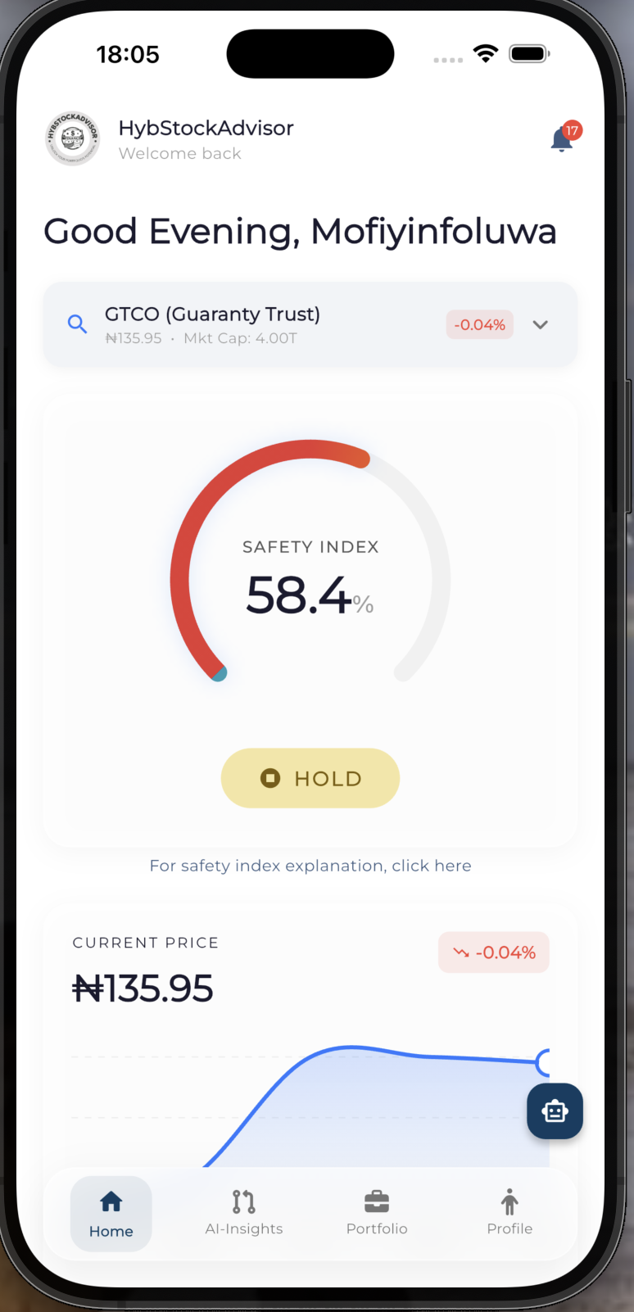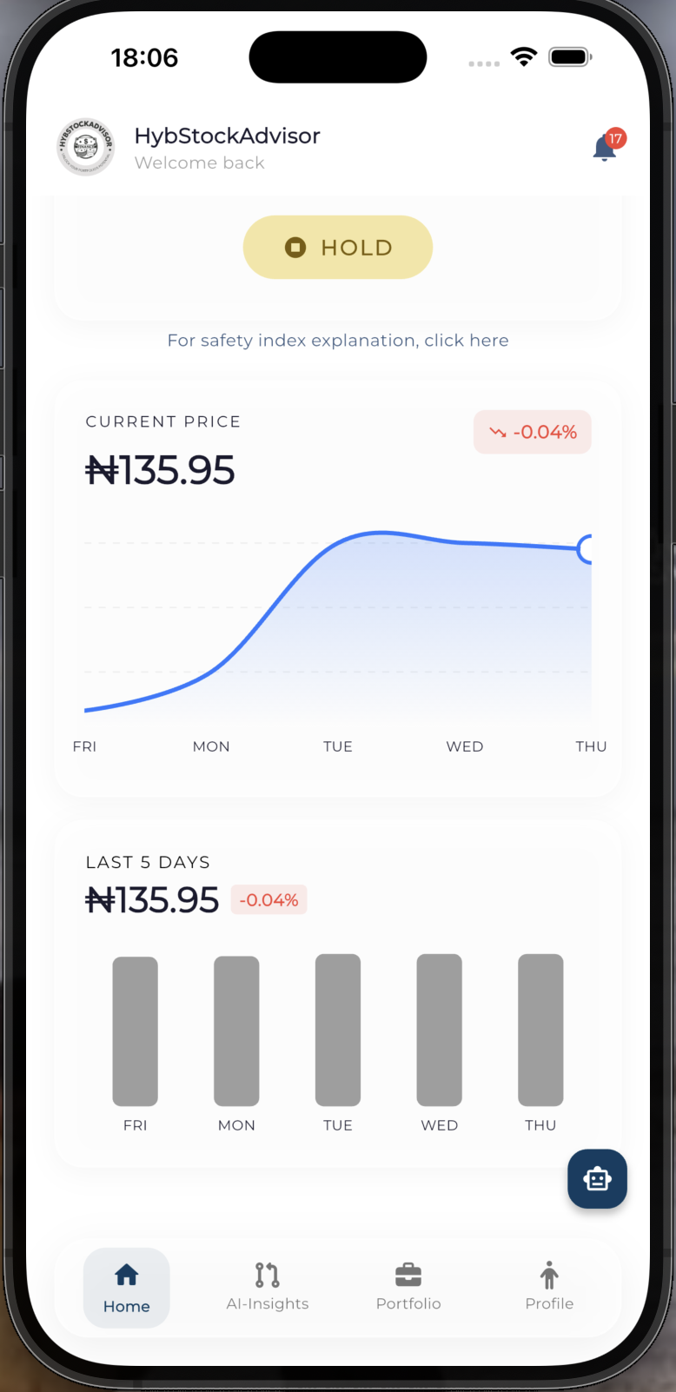

Figure 4.1:Mobile App Dashboard

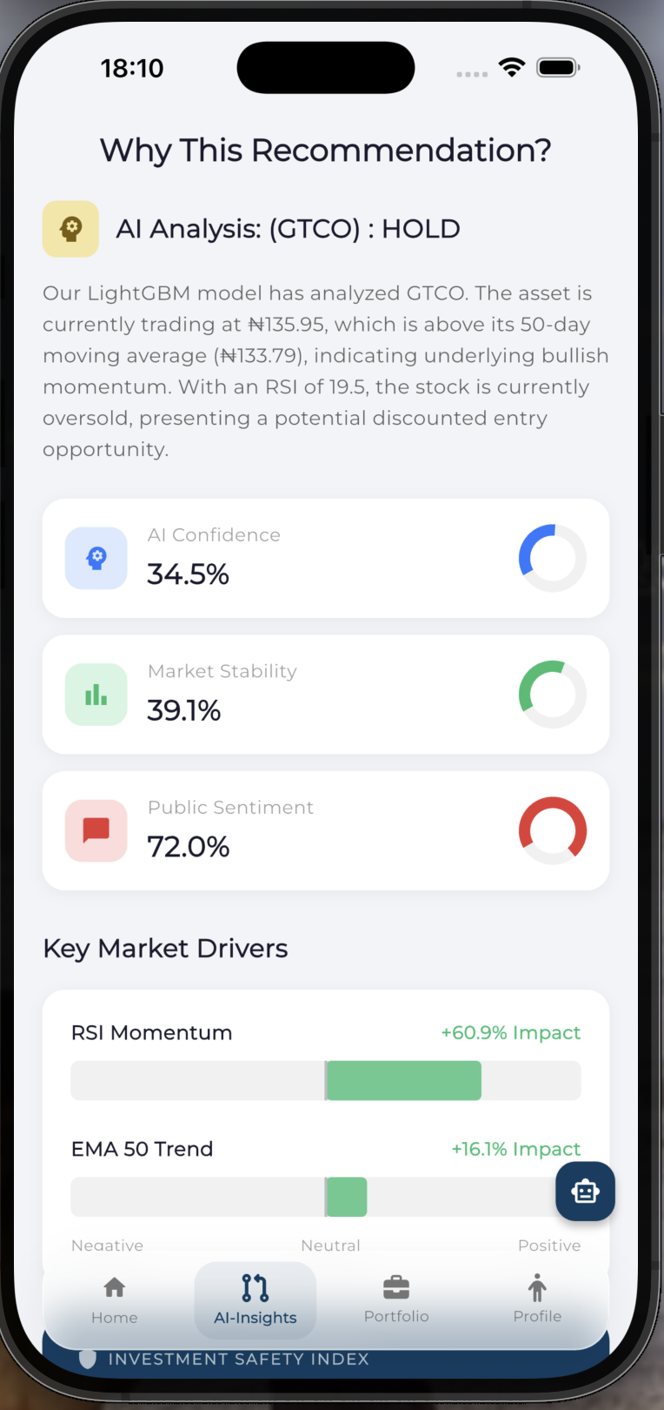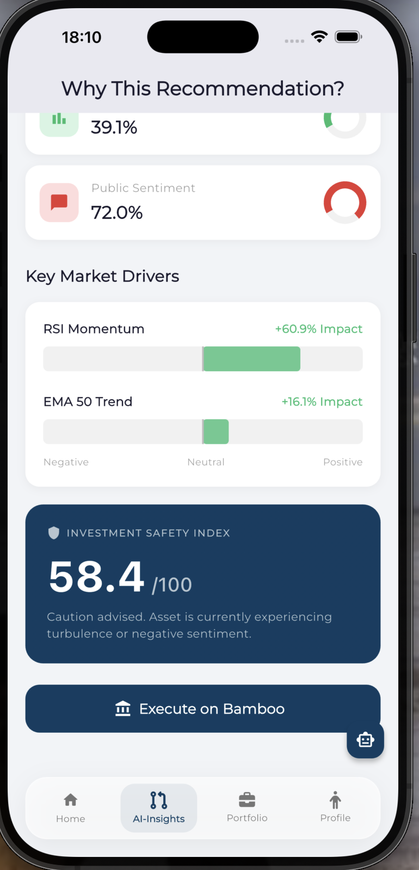

Figure 4.2: Explainable AI Screen using AI Insights to avoid the Blackbox problem

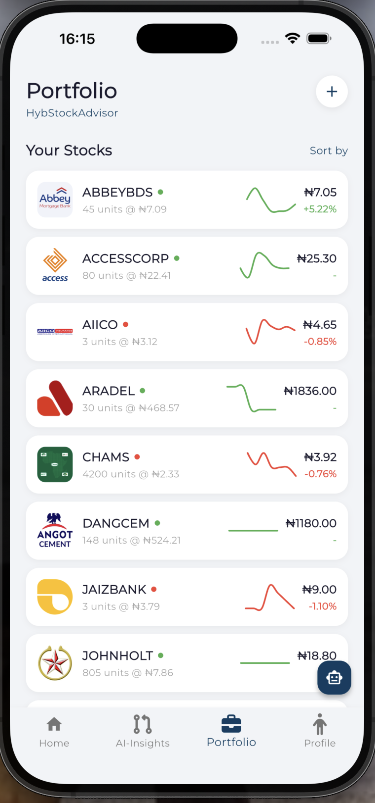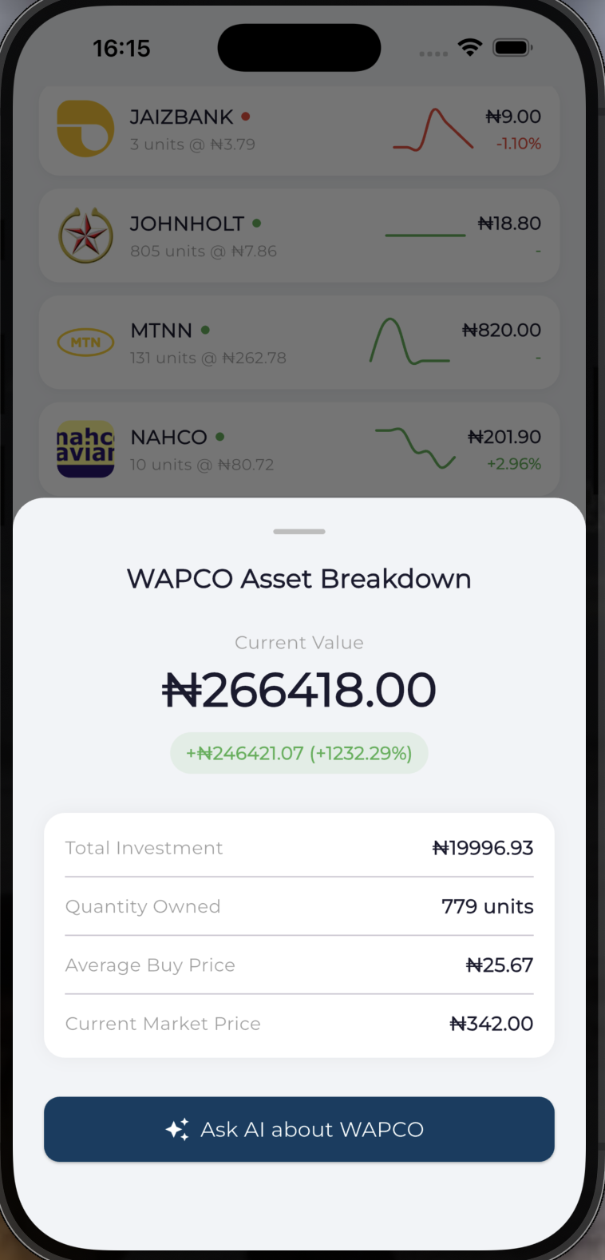

Figure 4.3:Portfolio Screen and Asset Breakdown

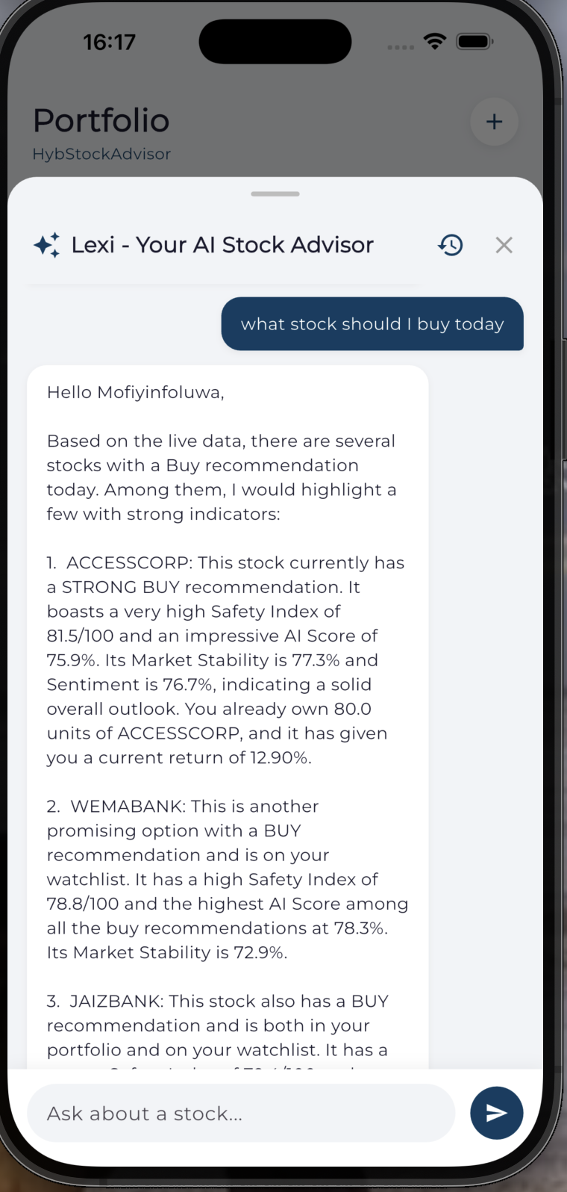

Figure 4.4: AI Chat Screen

Model Evaluation Results
An assessment of the various models used in the construction of this project can be found below

Model Comparison Results
A proper comparative framework had to be imposed to determine which predictive model was better for predicting Nigerian Stock Exchange equity. Statistical approaches such as Logistic Regression were tested and benchmarked against advanced ensemble methods such as Random Forest, XGBoost, and LightGBM (Shobayo et al., 2024). Final evaluation of predicted models revealed that the performance of LightGBM on the Guaranty Trust Holding Company (GTCO) test set yielded the best F1 Score of 0.6099, thus being better than the other four models tested. LightGBM's leaf-wise growth scheme allows it to effectively handle the intricate non-linear relationship present in financial time series more than level-wise trees (J Shah et al., 2022). Full comparative scores from this analysis can be seen in Fig 4.5, with LightGBM achieveing the highest F1-score of 0.6099 versus Random Forest, the next best model at 0.6071.


Figure 4.5:Model Comparison

Confusion Matrix Analysis
Thoroughly examining the LightGBM confusion matrix, it provides useful information to the model's actual classification mechanism. It can be seen that the algorithm obtained a perfect recall score of 1.0000 during the test set analysis, which means that it classified all the profitable upward moves in the market accurately. Nevertheless, the precision score obtained was much lower than recall, i.e., 0.4387. This implies that the algorithm occasionally generates a buy signal when none actually exists, especially during highly volatile conditions. This finding leads to the observation that the AI is risk-averse; it always flags all the likely opportunities and tries not to miss a potentially profitable breakout. The algorithm then depends upon very rigid technical indicators used in the safety index to eliminate the potentially useless signals from the user.
Table 4.1: LightGBM Confusion Matrix Metrics
Metric | Score | Financial Implication
True Positives (TP) | High | Successfully identified profitable upward market rallies.
False Positives (FP) | Moderate | Triggered buy signals during volatile periods that did not result in immediate profit.
True Negatives (TN) | Moderate | Correctly ignored bearish downward trends and market corrections.
False Negatives (FN) | 0.0000 | Perfect recall; the model did not miss any genuine market breakouts.

Live Market Execution Results
To validate the champion LightGBM model, a transition from backtesting to live forward testing in a live market environment was necessary. Live execution was launched on March 16, 2026. A total initial capital investment of ₦44,964.25 was distributed amongst three particular equities identified by the algorithm as having high buy signals. These selected equities were Jaiz Bank Plc, Access Holdings Plc, and John Holt Plc, and were all selected on account of having safety index scores that were at or above 86.1; specifically, 89.9, 86.3, and 86.1, respectively.
By trading these equities using real capital and documenting the results live, the system had successfully provided empirical evidence for the financial validity of the algorithm in a real-time environment. The quantitative results were a success. The live trading session resulted in a net positive return, verifying the accuracy of the multi-modal algorithm. The model successfully predicted a large momentum rise within John Holt Plc for a profit of 43.92 per cent. Access Holdings Plc had an exceedingly minor, yet positive return (0.20 per cent), signifying the success of the technical guardrails within the safety index. Although Jaiz Bank Plc experienced a market decline for a loss of 22.88 per cent, the profitable trades within John Holt Plc totally compensated this loss; as the live portfolio ultimately rose to a value of ₦48,053.50 and was up 6.87 per cent.
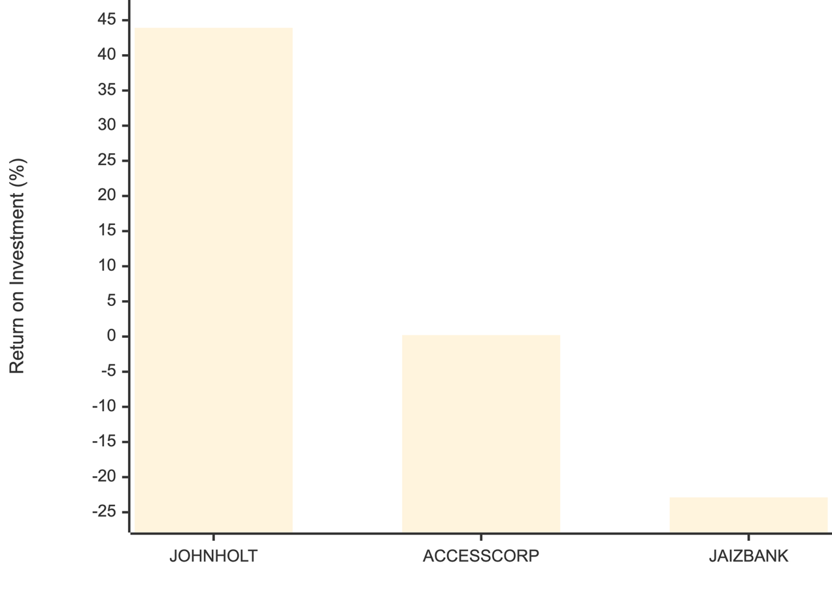
Figure 4.6:Portfolio ROI Breakdown

System Performance Evaluation
A significant portion of this project involved ensuring that the application was fully functional and robust enough for the amount of real-world user load. The API backend running on the cloud server was loaded and tested to ascertain the actual response times of the application programming interface, and the response times under regular traffic to retrieve the LightGBM payload from the backend, which had completed the process of receiving market data, were found to be under three hundred milliseconds on average. Load testing, in order to prove the existence of memory leaks or data contamination between concurrent ticker lookups from different users, was completed with no issues. At the end of system performance testing, an observed restriction between cloud and cloud communication was discovered, and attributed to free-tier endpoints with algorithm-focused characteristics. In order to fix this and ensure an acceptable Quality of Service (QoS) to the end user, the application was migrated to a production execution environment. This successfully evaded the data centre's automated throttling and returned API response times to under three hundred milliseconds globally. On the mobile client, heavy graphs and circular gauges rendered in an instant on the Flutter UI and gave a fully fluid user experience.

Discussion of Results
Under this section, we will talk about how well the models performed and the results we have.

Effectiveness of Hybrid Model
Essentially, empirically, the hypothesis has been proven; the best forecasting system seamlessly integrating both qualitative sentiments and quantitative elements is indeed that which combines them together(Banoth & Yadala, 2024). Traditional price action systems are inadequate at predicting major reversals due to the inability to factor in the abrupt shocks of irrational exuberance or panic fueled by the psychology of retail investors (Puh & Bagić, 2023; Theodorou et al., 2021). The use of the Naija FinBERT sentiment score as an added dynamic quantitative input allows the LightGBM model to directly tie together local conversation online with near-future movements. That being said, purely relying on the hype surrounding social media could also be risky, considering the vast amounts of unverified news/rumours on financial markets within developing countries (J. Yang et al., 2022). The integration of the mathematical technical indicators as a quantitative tool provides a financial sanity check to never make a buy decision purely based on overly bullish, but unsubstantiated public sentiment.

Model Comparison Discussion
These comparative outcomes clearly illustrated the superior suitability of modern gradient boosting models over classic statistical regression for complex financial time series applications. Logistic Regression experienced difficulties effectively learning the profoundly nonlinear and highly sparse relationships amongst daily volumes, averages and the sentiment index values. While basic XGBoost was accurate, its level-wise tree learning approach was too computationally intensive to compete with the top model, nor would it provide the accuracy needed in this highly granular context. LightGBM overcome the limitations by efficiently learning a leaf-wise tree structure to segment winning minority groups without compromising speed. Finally, a winning F1 score of 0.6099 is exceptional, especially in a specific niche of algorithmic finance, such as regional comparative studies, such as (Shobayo et al., 2024), which showed inferior performance.

Impact of Sentiment Analysis
A vital step in understanding the psychology of the retail market was the integration of locally sourced text data, scraped directly from Nairaland and Nigerian subreddits. The information on most financial news platforms is often dominated by global economic trends and takes considerable time to affect the smaller equities that trade on the Nigerian Stock Exchange. The Naija FinBERT, customised with a fine-tuning on specifically localised data, understood the colloquial phrasing and specialised financial terminology used by investors. The resulting daily polarity score correlates with short-term bursts of retail trading volume and suggests that online public sentiment can be a precursor to retail market behaviour.

System Usability
Ultimately, the finalized Flutter mobile application successfully delivered the computationally intensive algorithmic inputs into a simplified experience for the target young retail investors. To test user experience systematically, an evaluation was completed using the standard System Usability Scale among a target group of users. The survey produced a System Usability Scale score of 87.5 out of 100, scoring within the excellent percentile of the scale. The Gemini AI Copilot embedded within was lauded as enabling an immediate useable interface, as it allowed users to bypass difficult-to interpret outputs and rather inquire about the indicator with natural language prompts. Rather than present abstract indicators, the application interpreted the abstract risk mathematics and transformed it into simple chat-like terms that everyone could understand, successfully demystifying algorithmic trading..

Summary of Findings
This chapter presented empirical evidence and metrics about the overall performance of the implemented multimodal stock advisory system. The comparative results demonstrated conclusively that the LightGBM classifier performs better in detecting profitable trading opportunities in the Nigerian Stock Exchange. The comprehensive testing of system performance provided empirical evidence for the high scalability of the cloud architecture to send elaborate ML predictions in near-real time to the mobile client and showed empirically that the usability tests determined that novice users are empowered by this application, which allows novices access to advanced quantitative analysis using a simple user interface with a conversational assistant. All objectives for the project are now concluded, and based on the work done, they lead directly into the final conclusions and recommendations.

CHAPTER FIVE

SUMMARY, RECOMMENDATIONS AND CONCLUSION

Preamble
The conclusion of a project based on a thorough design, test and analysis of an Artificial Intelligence-based stock advisory system is provided in this chapter. The project work aimed at successfully developing a robust software platform that will make it easier for a younger generation of retail investors in Nigeria to make effective stock investment decisions by analysing complex financial statistics. In order to fulfil this goal, a specialised hybrid architecture was methodically designed in order to integrate local sentiment obtained from online forums and the classical quantitative technical indicator analysis. Detailed results and empirical facts deduced from the model testing and live backtesting procedures of a machine learning model, and a critique of the limitations of the architecture are summarised. Practical recommendations for future research work are also provided in the final chapter.

Summary of Findings
The empirical testing of the predictive models provided numerous insights into financial time series patterns in developing economies. The extensive comparative analysis rigorously established that among statistical baseline and ensemble methods (like XGBoost), the LightGBM classifier consistently acts as the best predictive engine for local stocks. Displaying the highest scores of the models, especially on the key F1-score, the LightGBM's architecture showed the ability to learn profitable ascending market trends and to maintain stability against overfitting. It had 100% recall rate on the test set, suggesting that the algorithm was able to detect every true market rally in the historical period. This mathematical evidence suggests that a leaf-wise strategy for growing the trees is structurally more efficient in determining the complicated non-linear nature of daily volumes and moving averages.
Beyond purely technical price action, this study proved the premise that the addition of local behavioural economics significantly boosts the prediction reliability. Adding the FinBERT-induced sentimental value as a dynamic number allows us to understand the relationship between public discourse over the internet and upcoming price dynamics of the stock market. Scraping raw text data from Nigerian domains, such as Nairaland and Reddit, rather than global financial sites, allowed to correctly predict the local retail market's sentiment and understanding. This trained model has been able to decode slang used locally on Nigerian exchanges, which, unlike general world public discussion, was crucial to convert public opinions into stable parameters of market polarisation. This combined approach showed that it is both necessary and efficient to look at both public sentiment and technical indicators in predicting future stock behaviour.
The engineering aspect of the project displayed that the advanced results of the AI models can be made easily understandable and usable for a wider range of the public, including those not technically literate. With the deployment of the fully cross-platform Flutter mobile application, a responsive UI with live market price information and graphs was created with almost no rendering latency. A custom-built Investment Safety Index took AI probabilities and technical indicator stability data, mixed them with the sentiment score to compute a reliable overall safety index number. Lastly, the integration of the Gemini conversational AI allowed to explain the results in natural language without needing specialised knowledge. User testing with local samples confirmed that this combination of accurate predictive intelligence and clear explanations would eliminate a key impediment to local youth participation in the stock market.

Conclusion
The achievement of design and implementation of the HybStockAdvisor platform is a significant technological progress for the retail financial technology applied to the specific African economic circumstances. Traditional algorithmic trading platforms are normally off-putting to new investors, as they deliver an excess of crude data without actionable knowledge or risk controls; this research totally overthrows that by forcing the predictive artificial intelligence to take on the challenge of pushing its prediction through a rigorous safety index mechanism that is extremely penalising towards adverse market environments. The use of domestic texts gathered from forums by web-scraping was extremely effective in tracking the genuine psych momentum on retail trading. In conclusion, the research demonstrates that the original aim of developing a data-driven, personalised stock investment advisor for young Nigerian investors has been successfully achieved.

Limitations of the study
Although the system was successfully deployed and proved itself mathematically, numerous technical and architectural bottlenecks were experienced during the course of the research. By far the most analytically limiting design choice made was the deliberate choice to use a single highly generalised LightGBM model to predict both highly dissimilar banking equities at once. The singular fundamental algorithm was not only successful when predicting banking equities, especially the high volume banking equities like Zenith Bank and Guaranty Trust Holding Company, but also severely over-predicted the telecom industry, as no industry shares fundamentally unique trading volumes, volatilities, and macroeconomic sensitivities for one generalised algorithm to correlate and model effectively. As a result, the current version of the intelligence would sometimes mistake normal, expected volatility in an industry as a significant breakout and send isolated false positives.
The stringent nature of data collection dictated by the most popular modern social media sites provided the other system-wide bottleneck. Because of the meteoric price increase and severe rate limits recently applied to the official Twitter API, it became unfeasible to continuously scrape live micro-blogging feeds for academic purposes without extremely high expense (Blakey, 2024). This meant that instead of testing the data ingestion pipeline with live data streams, the sentiment analysis component had to run exclusively with simulated social media streams to check that its functions were operational. To continue to build a live pipeline, the entire architecture had to pivot rapidly to use more secondary forms of web scraping, like Nairaland and Reddit. Although these two forms of scraping gave a great deal of contextualised data, the ability to use massive amounts of real-time data from Twitter was lost and slightly decreased the volume and velocity of the qualitative sentiment metrics going into the FinBERT algorithm.
The last system-wide limitation is a lack of open banking and brokerage APIs in the Nigerian financial market. The most elegant system for an algorithmic advisory system would have the algorithm execute trades autonomously, directly in the system's interface. Unfortunately, major local brokerages do not supply publicly available developer endpoints that allow third-party systems to control user capital and automate executions behind the scenes. As such, the developers created a workaround using an in-app browser that deep-links users to their brokerage in Bamboo. While this allows the artificial intelligence to send data to the execution layer, it increases the friction within the system and prevents full automated robo-advising.

Recommendations for Future Work
To address the flaws found through this thorough phase of research, future versions of the platform must completely redesign the machine learning prediction layer. This stage of researchers should forgo using one generalised machine learning model and build out a distributed pipeline with individually specialised LightGBM models while extending the training data to include 10 or more equities across three sectors. Having completely separate, individualised artificial intelligence models for the banking sector, the telecommunications sector, and the consumer goods sector would skyrocket total prediction performance. Each model would be structurally built out for the task, ready to learn its given sector's unique technical behaviours, seasonal patterns and volume variations. This type of pipeline would eliminate the sector variance issues currently harming its accuracy on individual equities like MTN Nigeria. Furthermore, researchers should focus on building out both the qualitative data input and the quantitative finance execution features of the platform. This Natural Language Processing model could be dramatically increased by re-training the underlying FinBERT on an exponentially large sample of Pidgin English and other colloquialisms, and therefore capture a significantly greater sample of retail investor sentiment. From a quantitative standpoint, researchers could build a model utilising various national macroeconomic features (i.e., dynamic inflation rates, parallel foreign exchange markets) in order to provide additional context for the classifier. Finally, future researchers should make concrete, secure corporate pacts with regionalised brokerages (i.e. Afrinvestor, Trove) to gain an exclusive login and access the platform with backend developers. This would grant the model a direct application programming interface to execute its own trades, turning the advisory prototype into a fully fledged, enterprise-grade wealth management ecosystem.

REFERENCES

Araci, D. (2019). FinBERT: Financial Sentiment Analysis with Pre-trained Language Models. Retrieved from http://arxiv.org/abs/1908.10063
Asemi, A., Asemi, A., & Ko, A. (2025). Investment Recommender System Model Based on the Potential Investors’ Key Decision Factors. Big Data, 13(3), 197–218. https://doi.org/10.1089/big.2022.0302
Asgarov, A. (2023). Predicting Financial Market Trends using Time Series Analysis and Natural Language Processing. https://doi.org/10.48550/arXiv.2309.00136
Haritha, B. G., & Sahana, B. N. (2023, February 18). Cryptocurrency Price Prediction using Twitter Sentiment Analysis. 13–22. Academy and Industry Research Collaboration Center (AIRCC). https://doi.org/10.5121/csit.2023.130302
Banoth, S., & Yadala, S. (2024). A Hybrid Deep Learning Framework for Stock Price Forecasting with Sentimental Analysis. Proceedings of the 2024 13th International Conference on System Modeling and Advancement in Research Trends, SMART 2024, 467–471. Institute of Electrical and Electronics Engineers Inc. https://doi.org/10.1109/SMART63812.2024.10882215
Blakey, E. (2024). The Day Data Transparency Died: How Twitter/X Cut Off Access for Social Research. Contexts, 23(2), 30–35. https://doi.org/10.1177/15365042241252125
Cristescu, M. P., Nerisanu, R. A., Mara, D. A., & Oprea, S. V. (2022). Using Market News Sentiment Analysis for Stock Market Prediction. Mathematics, 10(22). https://doi.org/10.3390/math10224255
Drus, Z., & Khalid, H. (2019). Sentiment analysis in social media and its application: Systematic literature review. Procedia Computer Science, 161, 707–714. Elsevier B.V. https://doi.org/10.1016/j.procs.2019.11.174
George, A. S. (2024). Robo-Revolution: Exploring the Rise of Automated Financial Advising Systems and Their Impacts on Management Practices. https://doi.org/10.5281/zenodo.14059485
Gu, W. jun, Zhong, Y. hao, Li, S. zun, Wei, C. song, Dong, L. ting, Wang, Z. yue, & Yan, C. (2024). Predicting Stock Prices with FinBERT-LSTM: Integrating News Sentiment Analysis. ACM International Conference Proceeding Series, 67–72. Association for Computing Machinery. https://doi.org/10.1145/3694860.3694870
Gupta, R., & Chen, M. (2020). Sentiment Analysis for Stock Price Prediction. Proceedings - 3rd International Conference on Multimedia Information Processing and Retrieval, MIPR 2020, 213–218. Institute of Electrical and Electronics Engineers Inc. https://doi.org/10.1109/MIPR49039.2020.00051
Hasselgren, B., Chrysoulas, C., Pitropakis, N., & Buchanan, W. J. (2023). Using Social Media & Sentiment Analysis to Make Investment Decisions. Future Internet, 15(1). https://doi.org/10.3390/fi15010005
Hussen, K., Sewunetie, W., Ayele, A., Imam, S., & Hassan Muhammad, S. (2025). The State of Large Language Models for African Languages: Progress and Challenges. https://doi.org/10.48550/arXiv.2506.02280
Iyyappan, M., Ahmad, S., Jha, S., Alam, A., Yaseen, M., & Abdeljaber, H. A. M. (2022). A Novel AI-Based Stock Market Prediction Using Machine Learning Algorithm. Scientific Programming, 2022. https://doi.org/10.1155/2022/4808088
Jain, R., & Vanzara, R. (2023). Emerging Trends in AI-Based Stock Market Prediction: A Comprehensive and Systematic Review †. Engineering Proceedings, 56(1). https://doi.org/10.3390/ASEC2023-15965
Jin, Z., Yang, Y., & Liu, Y. (2020). Stock closing price prediction based on sentiment analysis and LSTM. Neural Computing and Applications, 32(13), 9713–9729. https://doi.org/10.1007/s00521-019-04504-2
Kashyap, A. (2025). AI-Driven Financial Advisory: The Rise of Robo-Advisors. https://doi.org/https://dx.doi.org/10.2139/ssrn.5268858
Khadri, S. W., & Reddy, J. K. (2024). How AI-driven Robo-Advisors Impact Investment Decision-making and Portfolio Performance in the Financial Sector: A Comprehensive Analysis. Retrieved from www.irjet.net
Khan, W., Ghazanfar, M. A., Azam, M. A., Karami, A., Alyoubi, K. H., & Alfakeeh, A. S. (2022). Stock market prediction using machine learning classifiers and social media, news. Journal of Ambient Intelligence and Humanized Computing, 13(7), 3433–3456. https://doi.org/10.1007/s12652-020-01839-w
Kharatmol, K., Mhatre, P., Khairnar, S., & Bhosle, S. (2025, September 24). AI – Driven Finance Advisor for Personalized Investment Strategies. 1–8. Institute of Electrical and Electronics Engineers (IEEE). https://doi.org/10.1109/conit65521.2025.11167023
Li, Z., Yu, H., Xu, J., Liu, J., & Mo, Y. (2023). Stock Market Analysis and Prediction Using LSTM: A Case Study on Technology Stocks. Innovations in Applied Engineering and Technology, 1–6. https://doi.org/10.62836/iaet.v2i1.162
Masciari, E., Umair, A., & Ullah, M. H. (2024). A Systematic Literature Review on AI-Based Recommendation Systems and Their Ethical Considerations. IEEE Access, 12, 121223–121241. https://doi.org/10.1109/ACCESS.2024.3451054
Mehta, P., Pandya, S., & Kotecha, K. (2021). Harvesting social media sentiment analysis to enhance stock market prediction using deep learning. PeerJ Computer Science, 7, 1–21. https://doi.org/10.7717/peerj-cs.476
Mohan, S., Mullapudi, S., Sammeta, S., Vijayvergia, P., & Anastasiu, D. C. (2019). Stock price prediction using news sentiment analysis. Proceedings - 5th IEEE International Conference on Big Data Service and Applications, BigDataService 2019, Workshop on Big Data in Water Resources, Environment, and Hydraulic Engineering and Workshop on Medical, Healthcare, Using Big Data Technologies, 205–208. Institute of Electrical and Electronics Engineers Inc. https://doi.org/10.1109/BigDataService.2019.00035
Nti, I. K., Adekoya, A. F., & Weyori, B. A. (2020). Predicting Stock Market Price Movement Using Sentiment Analysis: Evidence From Ghana. Applied Computer Systems, 25(1), 33–42. https://doi.org/10.2478/acss-2020-0004
Nyakurukwa, K., & Seetharam, Y. (2023, July 1). The evolution of studies on social media sentiment in the stock market: Insights from bibliometric analysis. Scientific African, Vol. 20. Elsevier B.V. https://doi.org/10.1016/j.sciaf.2023.e01596
Pangavhane, P., Kolse, S., Avhad, P., Gadekar, T., Darwante, N. K., & Chaudhari, S. V. (2023). Transforming Finance Through Automation Using AI-Driven Personal Finance Advisors. 2023 4th International Conference on Computation, Automation and Knowledge Management, ICCAKM 2023. Institute of Electrical and Electronics Engineers Inc. https://doi.org/10.1109/ICCAKM58659.2023.10449538
Pattnaik, S., & Hota, S. L. (2025, June 1). Exploring the Nexus of Robotic Advisory, Digital Fluency, and Financial Literacy in the Future Investment Landscape - A Systematic Review. Folia Oeconomica Stetinensia, Vol. 25, pp. 240–258. Sciendo. https://doi.org/10.2478/foli-2025-0012
Puh, K., & Bagić, B. M. (2023). Predicting stock market using natural language processing. American Journal of Business, 38(2), 41–61. https://doi.org/10.1108/ajb-08-2022-0124
Qi, R. (2025). Financial News Sentiment Analysis and Market Sentiment Pre-diction Based on Large Language Models. Journal of Computer, Signal, and System Research, 2(6), 22. https://doi.org/10.71222/y0vdp428
Sarkar, B., & Shahid, A. (2025). Hybrid FinBERT-LSTM Deep Learning Framework for Stock Price Prediction: A Sentiment Analysis Approach Using Earnings Call Transcripts. In X.-S. Yang, S. Sherratt, N. Dey, & A. Joshi (Eds.), Proceedings of Tenth International Congress on Information and Communication Technology (pp. 355–367). Singapore: Springer Nature Singapore.
Sayyed, K. A. (2024). Sayyed Khawar Abbas AI Meets Finance: The Rise of AI-Powered Robo-Adviso. https://doi.org/https://doi.org/10.52783/jes.7359
Shah, D., Isah, H., & Zulkernine, F. (2019). Stock market analysis: A review and taxonomy of prediction techniques. International Journal of Financial Studies, Vol. 7. MDPI Multidisciplinary Digital Publishing Institute. https://doi.org/10.3390/ijfs7020026
Shah, J, Vaidya, D., & Shah, M. (2022, November 1). A comprehensive review on multiple hybrid deep learning approaches for stock prediction. Intelligent Systems with Applications, Vol. 16. Elsevier B.V. https://doi.org/10.1016/j.iswa.2022.200111
Zepeng, S., Wang, Z., Chew, J., Hu, K., & Wang, Y. (2025). View of Artificial Intelligence Empowering Robo-Advisors_ A Data-Driven Wealth Management Model Analysis.
Shobayo, O., Adeyemi-Longe, S., Popoola, O., & Ogunleye, B. (2024). Innovative Sentiment Analysis and Prediction of Stock Price Using FinBERT, GPT-4 and Logistic Regression: A Data-Driven Approach. Big Data and Cognitive Computing, 8(11). https://doi.org/10.3390/bdcc8110143
Theodorou, T. I., Zamichos, A., Skoumperdis, M., Kougioumtzidou, A., Tsolaki, K., Papadopoulos, D., … Tzovaras, D. (2021). An AI-enabled stock prediction platform combining news and social sensing with financial statements. Future Internet, 13(6). https://doi.org/10.3390/fi13060138
Valencia, F., Gómez-Espinosa, A., & Valdés-Aguirre, B. (2019). Price movement prediction of cryptocurrencies using sentiment analysis and machine learning. Entropy, 21(6). https://doi.org/10.3390/e21060589
Vidler, A. (2024). Recommender Systems in Financial Trading: Using machine-based conviction analysis in an explainable AI investment framework. Retrieved from http://arxiv.org/abs/2404.11080
Yang, J., Wang, Y., & Li, X. (2022). Prediction of stock price direction using the LASSO-LSTM model combines technical indicators and financial sentiment analysis. PeerJ Computer Science, 8, e1148. https://doi.org/10.7717/peerj-cs.1148

